# 

# **Intelligent Robotic Sewing for**

# **Personalized Stent Graft Manufacturing**

Early Stage Review

**Yang Hu**

Imperial College London

September, 2015

*Supervisor*: Professor Guang-Zhong Yang

**Contents**

[1 Introduction 4](#_Toc428951569)

[1.1 Motivation 4](#_Toc428951570)

[1.2 Objective 6](#_Toc428951571)

[1.3 Contributions 6](#_Toc428951572)

[2 State-of-the-Art Stent Graft Sewing Method 7](#_Toc428951573)

[2.1 Stent Graft Material and Hand Sewing 7](#_Toc428951574)

[2.1 Automated Stent Graft Sewing 8](#_Toc428951575)

[3 Literature Review on Industrial Sewing 10](#_Toc428951576)

[3.1 Sewing Machines and Stitching Types 10](#_Toc428951577)

[3.2 3D Single Sided Sewing 10](#_Toc428951578)

[3.3 Intelligent Robotic Sewing 12](#_Toc428951579)

[4 Literature review on Surgical Suturing 15](#_Toc428951580)

[4.1 Surgical Stitching and Knotting types 15](#_Toc428951581)

[4.2 Assistant Suturing Device 16](#_Toc428951582)

[4.3 Robotic Assisted Suturing and Automated Suturing 18](#_Toc428951583)

[4.3.1 Tissue Piercing 18](#_Toc428951584)

[4.3.2 Knot Tying 20](#_Toc428951585)

[4.3.3 Visual Guidance 21](#_Toc428951586)

[5 Multi-Robots Stent Graft Sewing Experiment 22](#_Toc428951587)

[5.1 Co-operative Robots Motion Planning/Control 22](#_Toc428951588)

[5.1.1 The Relative Jacobian 23](#_Toc428951589)

[5.1.2 Prioritized Closed-Loop Inverse Kinematic Control 24](#_Toc428951590)

[5.1.3 Preserving Task-Priority under Joint Limits 25](#_Toc428951591)

[5.2 Simulation Study 28](#_Toc428951592)

[5.2.1 Simulation Study 1 (Task Conflicts Handling) 28](#_Toc428951593)

[5.2.2 Simulation Study 2 (Joint Constraints Handling) 31](#_Toc428951594)

[5.3 Experiment Study for 3-D Stent Graft Sewing Task 32](#_Toc428951595)

[5.4 Conclusion 34](#_Toc428951596)

[6 A Suturing Device with Programmable Needle Trajectory 36](#_Toc428951597)

[6.1 Requirements Analysis 36](#_Toc428951598)

[6.2 Prototyping 37](#_Toc428951599)

[7 Conclusion and Future Work 40](#_Toc428951600)

[Reference 42](#_Toc428951601)

1 Introduction

1.1 Motivation

Stent grafts are tubular shape implants for supporting diseased vessels caused by abdominal aortic aneurysm (AAA). Generally, stent grafts comprise two components: a quasi blood-tight textile tube called graft and a reinforcing metallic ring called stent. In many designs, the reinforcing rings are attached to the surface of the graft by means of sutures which are generally applied by hand. The method for sewing stent graft is very similar with the suturing in medical filed, in which a circular needle and a needle holder are used to close tissue gap. The most commonly seen stitch types in stent graft products are tack stitch (knotting after each stich) and running stitch (continuous sewing).

The use of standard stent graft may lead to an inadequate seal of the aneurysm sac; migration may happen in long-term. To solve this problem, personalized, custom made stent-grafts (Fig. 1.1) with better fit for a patient’s anatomy are emerging as an appealing solution [54]. The

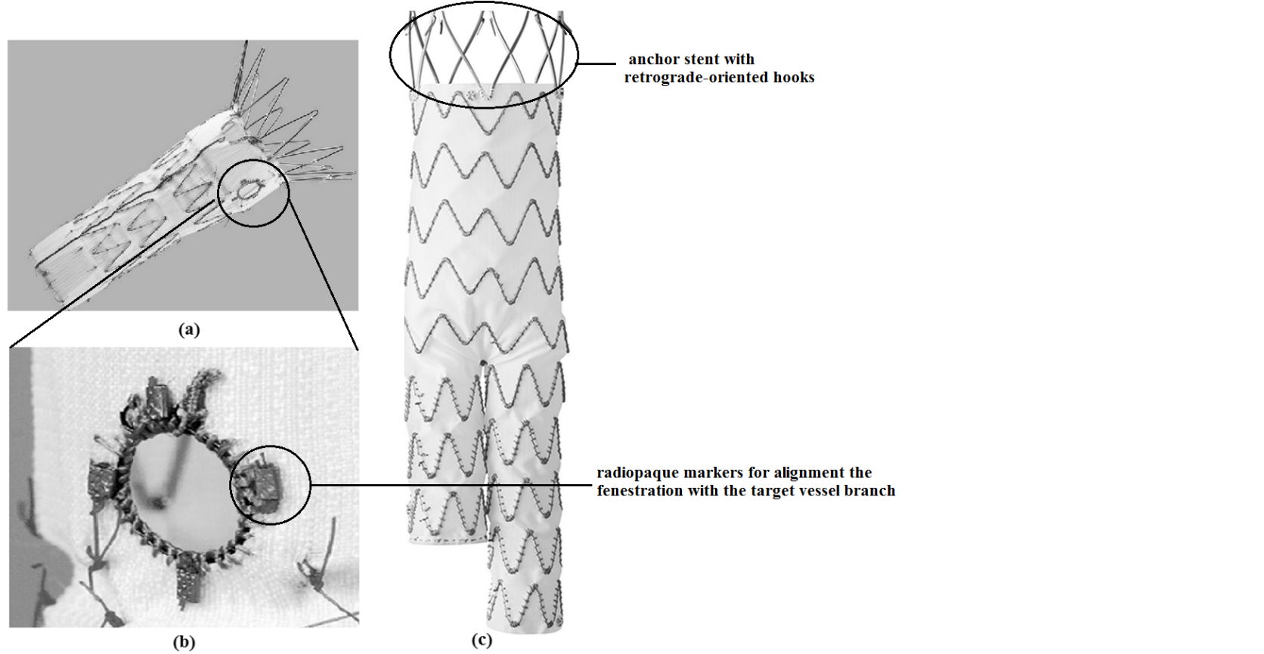

Fig. 1.1 Customized Stent Graft (a) Fenestrated stent graft (Photo: Cook Medical Inc.)

(b) Fenestration sewed with blanket stitch. (Photo: Cook Medical Inc.)

(c) Medtronic branched stent graft sewed with running blanket stitch. (Photo: Medtronics Ltd.)

fenestrated stent graft creates holes on its surface, which can be aligned with, for example, renal arteries, allowing the proximal fixation and sealing site of the graft to be moved upwards into a more healthy section of the aorta. A branched stent graft allows for secure exclusion of the aneurysm while maintaining vital perfusion to the renal and mesenteric arteries. These personalized stent graft with complex shape are employed with many hundreds or thousands of sutures. Currently, the manufacturing of these device can take 6-12 weeks. The time associates with attaching sutures for manufacturing a custom-made stent graft is long. The burden of assuring the quality of every stitch is also expensive. For patient with complex dilemma, waiting for the delivery of a custom-made stent graft creates unparalleled health risk.

The development of an automated or partially automated stent graft sewing technique would be very helpful to change the status quo. Recent innovation on 3D structured object sewing is an important topic for innovative manufacturing. Extensive research has been carried out on developing singled sided sewing heads which are able to work on 3D objects with closed surface. For example, [KSL Keilmann](http://www.ksl-lorsch.de/) (Lorsch, Germany) [1] has develop various 3D stitching systems incorporating single sided sewing heads onto KUKA manipulators for sewing fabric-reinforced structure of aircraft parts. Automated sewing has been also widely researched in textile industry. Intelligent robotic systems with multi-sensor feedback are built to solve the most significant problem in this filed -- soft/limp material handling. By leveraging on the use of force/torque, optical and visual sensors, proper fabric tension control and accurate sewing seam tracking are achieved with advanced planning, control and learning framework.

The technique of applying thread to band objects does not only exist in the field of industrial sewing. As the widely introduction of robotic assisted systems in the field of minimally invasive surgery, an automated suturing process could benefit the surgical process with machine speed and accuracy. For example, Hager et al. 2011[2] researched on implementing an automated mode on Da Vinci surgical robot, which is able to alleviate a surgeon’s burden on robotic suturing. Suturing automation is emerging as a promising topic for the promotion of surgery quality. With this purpose, extensive research has been contributed from “software” side. Needle path planning, optimization, suturing skill learning and vision guided suturing are all important topics in this filed. On the other hand, innovations is also being taken in the hardware designs side. Various assistant suturing devices have emerged in the market with the innovative mechanisms to make surgical suturing relative easier by automating or partially automating the tissue piercing and knot tying procedures.

The report reviews state-of-the-art techniques of applying threads to band objects, especially how this process is being automated and robotized. Two fields, industrial sewing and surgical suturing, are separately reviewed. Targeting at sewing and suturing automation, the review starts with a survey on hardware design and ends with how robots and machine intelligence are playing increasingly important role in each filed.

1.2 Objective

As mentioned above, many research issues related to the stent graft sewing are open and yet to be investigated. System level solutions for fenestrated/branched stent graft sewing are gradually formed during the process of reviewing literature, experimenting, participating industrial exhibition, and discussing with my supervisor and other collaborators from both clinical and industrial side.

(1) Building a bimanual robot system able to learn the sewing skills from human demonstration. Two needle drivers, a circular needle and conventional hand sewing method are used in the initial stage.

(2) Prototyping a new sewing device which could partially automate the sewing process and eventually mounting it on the articulated KUKA robot for fully automated sewing.

(3) The research on visual guidance/servoing technique for adapting the learned skill to environmental changes.

1.3 Contributions

(1) A study on the existing technology for stent graft sewing and an investigation on the available techniques for indusial sewing and medical suturing automation.

(2) Theoretical research on robot bimanual co-operative control under task conflicts and joint constraints (Published as a conference paper in IROS 2015)

(3) Finish the first prototype for a new sewing device which could partially automate the sewing process.

2 State-of-the-Art Stent Graft Sewing Method

**2.1 Stent Graft Material and Hand Sewing**

Since the invention of stent graft by Dr. Parodi, the configuration and the materials used for making a stent graft are not significantly changed. Grafts are mainly made of expanded polytetrafluoroethylene (PTFE) or polyester (PET, Dacron). The most common stent material is Nitinol, a nickel titanium alloy or stainless steel. The two largest stent graft manufactures, Cook Medical and Medtronic both use suturing to band the stent with graft. Nevertheless, other methods, like thermal process, are used. The sutures they use are similar with surgical sutures which are highly durable biocompatible material. Examples include synthetic fibers made from polyamides (nylon), polyolefins (polyethylene, polypropylene), polyesters (Dacron), polybutesters, and high molecular weight polyethylene.

Currently, most fenestrated/branched stent grafts are hand sewed (Fig. 2.1). The sewing method requires first to draw a pattern on the graft fabric to indicate where stents are placed [3]. Either tacking stitch or running stitch following the stent is used for banding the stent with graft. In addition, to prevent the fenestration edge from fraying, stitch is frequently added for edge finishing. Furthermore, knotting is used to secure a stitch, especially for small stent grafts, which are not suitable for using running stich. The process of hand sewing is slow and easily associated with human errors. Increased variance in manufacturing tolerances is unavoidable. Drawing or marking also has the potential to contaminate or damage graft fabric.

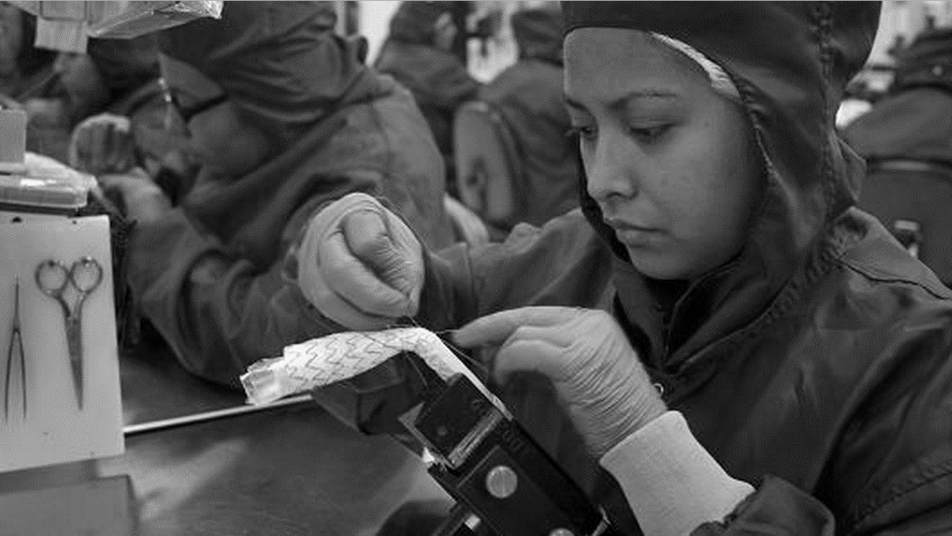

Fig.2.1 A scenario of stent graft sewing (factory of Medtronic Ltd, Mexico City, Photo: [Bloomberg](http://www.gettyimages.co.uk/search/2/image?artist=Bloomberg&family=editorial) )

**2.1 Automated Stent Graft Sewing**

Conventional sewing machine is introduced to automate the stent graft sewing process. For example, in the patent disclosed by [Anson Medical](https://www.google.com/search?tbo=p&tbm=pts&hl=en&q=inassignee:%22Anson+Medical+Limited%22) Ltd [4], a computerized sewing machine is used to sew a flat-form device which is later rolled into a tubular shape. This kind of method results in a seam and it is not suitable for sewing complex fenestrated/branched stent graft designs.

Due to the fact that conventional sewing machine only targets at working on flat surface, sewing machine has been customized in order to directly sew on the surface of a tubular shape stent graft, for example a such machine was disclosed in the patent disclosed by Phillips et al. (2007 [51]). Our collaborator Medical Sewing Solution LLC (San Francisco, US) has also invented a computerized sewing system, which has an elongate sewing arm which is able to work inside a stent graft. Depending on the stitch types used, different sewing mechanisms, bobbin for lock stitch or looper for chain stitch, could be built inside the elongate structure. The system also features a stent graft holding component, called mandrel (Fig. 2.2 b), which works in conjunction with the sewing machine. On the surface of the mandrel, special grovels are designed to fix the stents in position. Holes are laid out along the grooves for passing the sewing needle. In addition, the mandrel is fixed on a two-degree-of-freedom platform which is able to rotate and translate the stent graft along its longitudinal direction. Another feature of the mandrel is that its body is able to be divided into serval pieces in radial direction and can shrink inside for easily taking the stent graft out after the sewing finished.

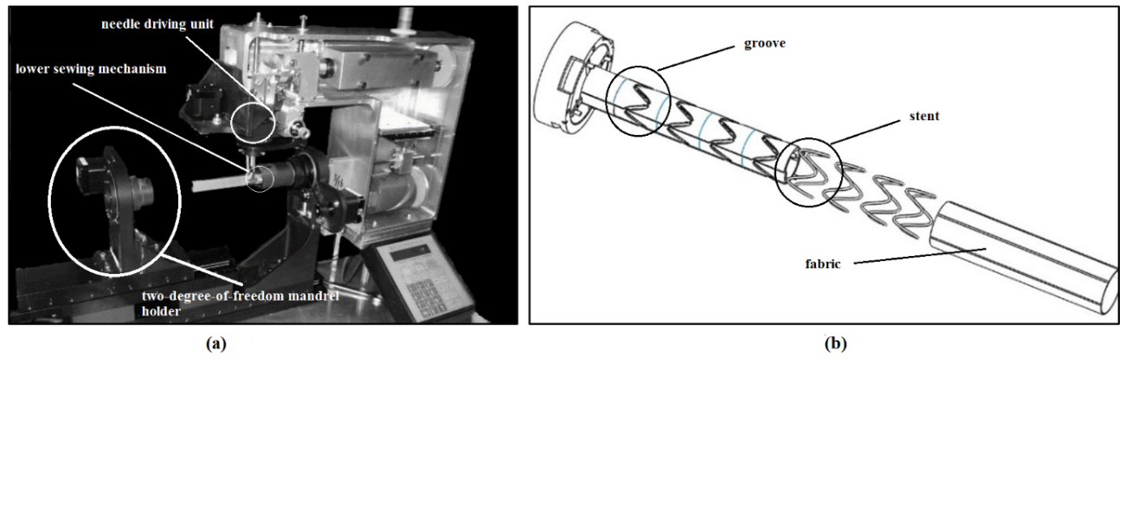

Fig.2.2 Stent graft sewing system (a) the sewing machine (Photo: Medical Sewing Solution LLC)

(b) the mandrel with the stents and graft

These customized sewing machines commonly apply lock stitch or chain stitch to sew stent grafts. Since it is no way to secure a stich using knotting, back and forth stitching is commonly made at the beginning and ending of sewing. Compared with handmade stitch, such as blanket stitch, machine stitches are messy and easily coming out from the fabric once any point breaks. A sewing machine (Fig. 2.3) which mimic hand sewing is developed thereby by Medical Sewing Solution. This sewing machine designed with a straight needle passing between two moving arms. Special thread pulling mechanism with force sensing ability is incorporated to tighten each stitch. Materials on how the thread pulling mechanism works and how the machine is applied to medical device manufacturing are absence due to secrecy.

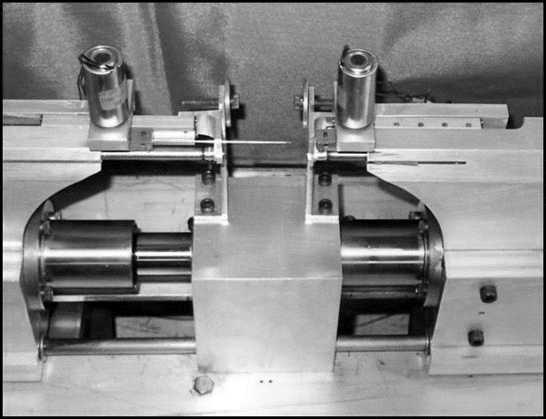

Fig. 2.3 Hand stitch (205) sewing machine with double pointed needle. (Photo: Medical Sewing Solution LLC)

Vision system is used for guiding the sewing process. However, due to this is the top secret there is no material disclosed on how visual guidance functions in the automated stent graft sewing process. Nevertheless, the technique developed targets at sewing standard stent graft devices with simple cylindrical shape, which is not suitable for sewing complex fenestrated/branched stent graft.

At current stage, almost all customized fenestrated/branched stent grafts are hand sewed. Their quality relies on the worker’s sewing skill. The fact is due to there is no available sewing technique could sew small 3D structure and there is no system could deal with sewing, knotting and edge finishing at the same time.

3 Literature Review on Industrial Sewing

**3.1 Sewing Machines and Stitching Types**

Sewing machines can make a great variety of plain or patterned stitches. Most of them fill into three categories according to their stitch types, [chain stitch](https://en.wikipedia.org/wiki/Chainstitch), [lock stitch](https://en.wikipedia.org/wiki/Lockstitch) and [overlock](https://en.wikipedia.org/wiki/Overlock) stitch.

Singe thread chain stitch is as Fig.2.1 (a). This stitch is made by passing the new loop through the previous loop during each stitching. This stitch is not self-locking, making the whole length of stitching easily come out once any point breaks. Double chain stitch sewing machine was later invented to address this problems. A second thread is applied to hook the first thread in place. One problem of chain stitch is that the direction of sewing cannot be changed much from one stitch to the next because the constraints of its sewing mechanism.

As a better solution than chain stitch, a lock stitch sewing machine was invented and becomes today’s most common [sewing machine](https://en.wikipedia.org/wiki/Sewing_machine)s. The lock stitch is lighter but stronger than chain stitch. Formation of a basic lock stitch requires using two threads, an upper and a lower. The two threads interlaced with the other in the hole in the fabric which they pass through (Fig. 2.1 b). To make one stitch, the entire lower thread is required to go through the loop formed by upper thread. A boat shuttle mechanism (Fig. 2.2 a) was designed in earlier lock stich machines. Later it was replaced by a more effective rotating hook (Fig. 2.2 b), which is able to catch the upper thread loop around the lower thread sitting in the bobbin case.

In order to prevent the fabric from fraying and falling apart, an overlock stitch is added to create a clean edge. [Overlock](https://en.wikipedia.org/wiki/Overlock) stitch, also known as "serging" or "serger stitch", is a kind of stitch that sews over the edge of one or two pieces of cloth for edging, hemming, or seaming. The mostly common used overlock stitch is shown in Fig.2.1 c.

**3.2 3D Single Sided Sewing**

Most sewing machine use two or more threads for sewing. Traditional industrial sewing machines require two synchronized parts working at each side of the fabric. The need for accessing sewing part from both sides makes it impossible to apply stitches to a 3D structure with closed surface. To overcome this restriction, various single sided sewing heads are

**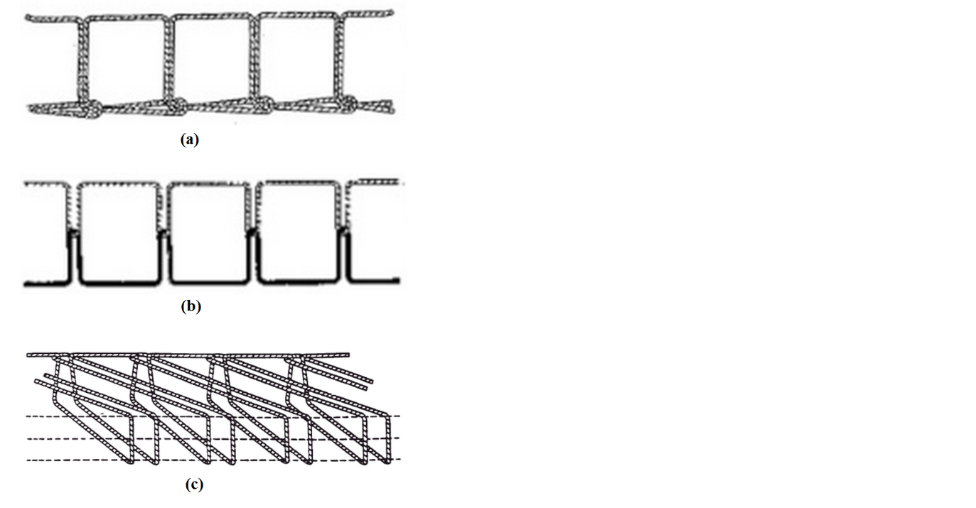**

Fig.3.1 (a) single thread chain stitch 100 (b) lock stitch 301 (c) overlock stitch 500 (edge finishing stitch)

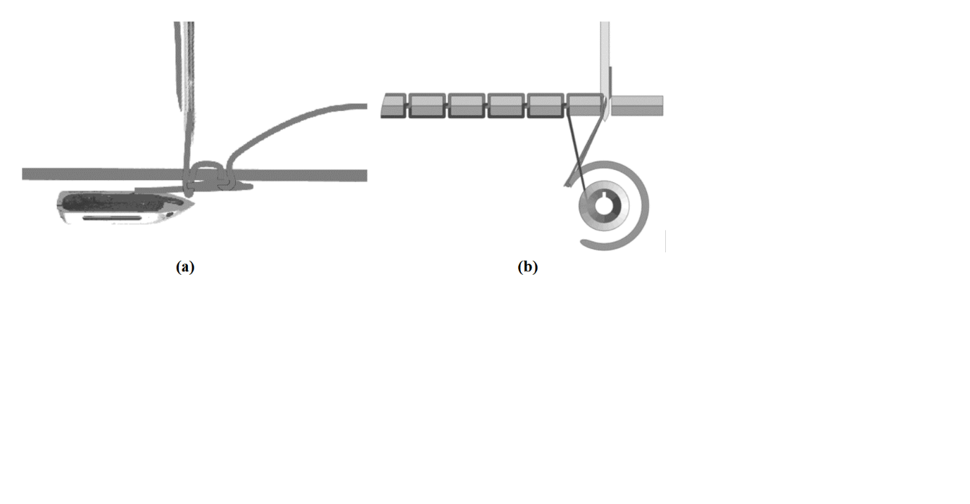

Fig.3.2 two lock stitch sewing mechanisms (a) shuttle boat mechanism (b) rotary hook mechanism

developed (Murai et al. 2013) [5]. Multi-joint robot arms are used to accurately position these sewing heads. This so-called 3D single sided sewing technology are playing increasingly important role in today’s automobile and aviation industries. Examples of these sewing machines include the ITA sewing head (the Institute of Textiles, University RWTH Aachen) (Fig 3.3 a) using two triangulated needles to sew chain stitch (Fig. 3.4 a). The single sided sewing head from Altin Textima (Brandenburg, Germany) uses a sewing needle at 45° and a 90° hook needle (Fig. 3.4 b). This setup lays the thread chain on the upper side of the fabric and produces a simultaneous reinforcement at 90 and 45°. Another sewing head designed by KSL (Fig. 2.3 b) uses a curved needle (Fig. 3.4 c), which also puts the thread chain on the upper side of the material. With this sewing head, the needle does not puncture through the material, so it is also called blind stitch. In order to accurately attach stitches on the object being sewn, these sewing heads are mounted on robotic systems, such as ITA using parallel manipulator or KSL using KUKA serial manipulator.

**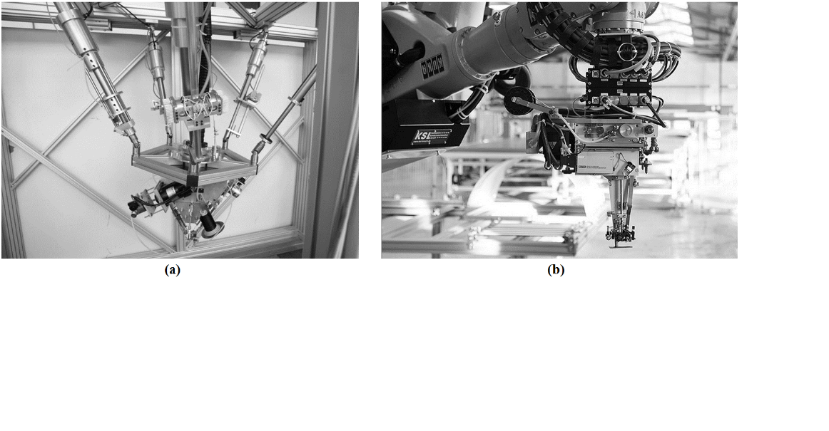**

Fig.2.3 Single sided Sewing head (a) ITA double needle sewing machine building on a parallel robotic structure (Photo: [IGM - RWTH Aachen](https://www.google.com/url?sa=t&rct=j&q=&esrc=s&source=web&cd=1&ved=0CB0QFjAAahUKEwil9LH__MbHAhXLVRoKHW4mCkk&url=http%3A%2F%2Fwww.igm.rwth-aachen.de%2Findex.php%3Fid%3D617..%252F..%252F..%252F..%252F..%252F..%252F..%252F..%252Fetc%252Fpasswd%2500%26L%3D2&ei=h8_dVeWUO8urae7MqMgE&usg=AFQjCNExQivUV4RkwXiW12OX6gN5M5z8HQ&sig2=3khEZvEGq40u43OWMe0zrw)) (b) KSL Blind stitch sewing machine, using a curved needle and a hook and mounting on a KUKA robot manipulator (Photo: [KSL Keilmann](http://www.ksl-lorsch.de/))

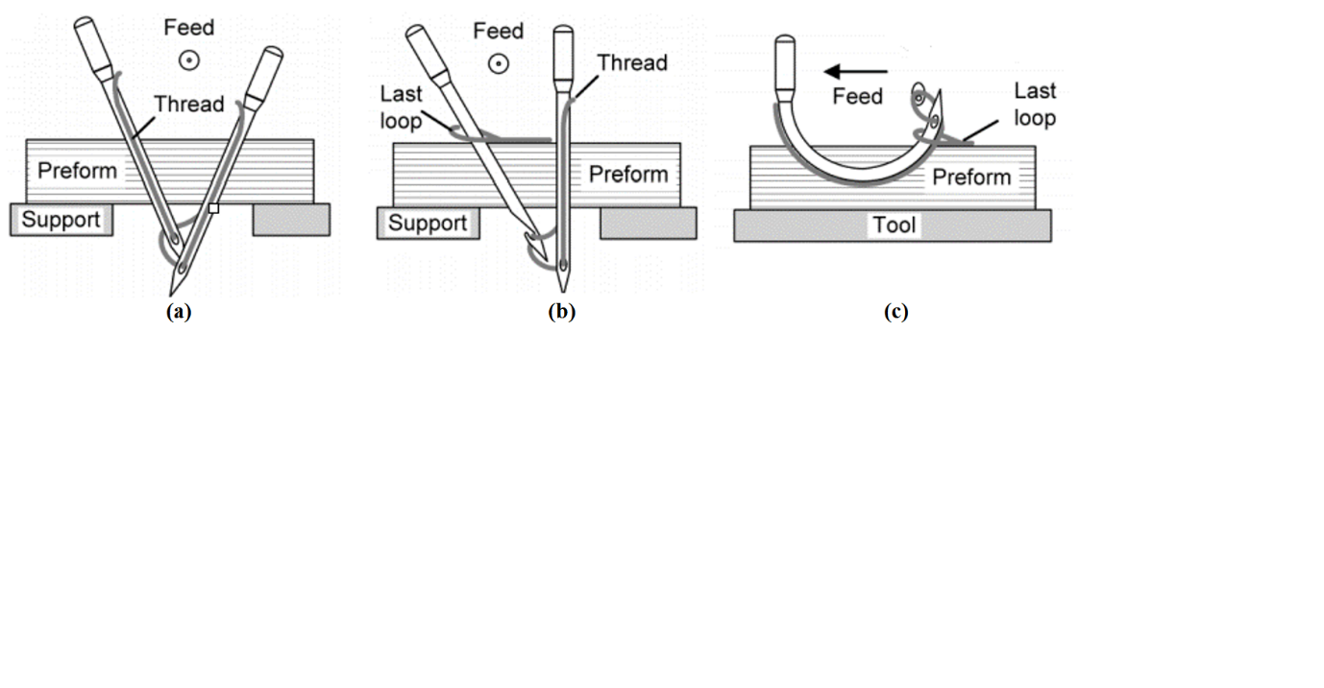

Fig. 3.4 Single sided sewing mechanisms: (a) ITA sewing head uses triangulated needles (b) ALTIN sewing head used a needle and a hook (c) KSL blind stitch with a curved needle and a hook

3D single sided sewing technique is only seen in applications in which threads is applied to relatively large object, for example aircraft part. To apply this technique to small object, like stent grafts, the sewing heads need to be redesigned to avoid threading heavily and creating too much puncturing holes, which could cause thrombosis and endo-leak. In addition, even though robotic systems were used for sewing 3D structure, this type of sewing technique cannot be adapt to changes in the environment. The needs for reprogramming to fit new sewing task limits its application.

**3.3 Intelligent Robotic Sewing**

The industrial sewing process is still labour intensive and less automated compared with others manufacturing processes, such as arc welding, car assembling, etc. The main challenge which impedes automating sewing process is the need to deal with limp and deformable material. Most of previous research on robotic sewing are therefore targeted at enabling robots handle deformable fabric like a human. To achieve this purpose, sensory feedback, tension control and visual servoing are included. Sophisticated adaptive control systems that accommodate environmental changes are also developed. One step further than automated sewing, we classify intelligent robotic sewing as the techniques and systems that involve robots or intelligent agents that are able to adapt their behaviour to changes in the sewing environment.

An earlier work of intelligent robotic sewing is the FIGARO system (Gershon and Porat,1986 [7], 1988 [8]), which contains an articulated robot with two end-effectors, a conventional sewing machine, vision system and a force sensor mounted on one of the two end-effectors. The two end-effectors are responsible for feeding the fabric into a fixed sewing machine and controlling the orientation of the fabric. With force and vision feedback and each respective control loop, proper tension and constant seam width are maintained. In order to execute the task in a similar manner as the human operator does, bimanual robotic sewing was widely researched, Kudo et al., 2000 [9], Schrimpf et al., 2012 [10] [11] 2014 [12]. Tension control and seam tracking control as two necessary parts of robot sewing are refined by introducing new sensors and methods in their work. Pattern sewing requires a precise control of the fabric feeding direction. The most common pattern is a straight line. State-of-the-art sewing machines with laser guide can project a perfect straight laser beam onto the fabric to guide the human operator. In the work of Biegelbauer et al.’s (2007 [13]), a laser beam was projected onto the seam to be sewed By an interpretation of the geometrical relation between the sewing seam and laser beam in the camera image, an accurate sewing trajectory tracking can be achieved. Nevertheless, other types of optical sensor system have also been proposed. A 1-D optical sensor array, which can measure the amount of light in each pixel, was used for controlling the edge distance ([10] [11] [12]).

To cope with environmental changes which are implicit in sensory feedbacks, various control strategies are implemented. To maintain a proper tensional force to fabric, a fuzzy logic controller was derived by mimicking human sewing (Panagiotis, et al. 2006 [14]). In the work of Kudo et al. [9], a hybrid position/force control was used by considering that each arm of the

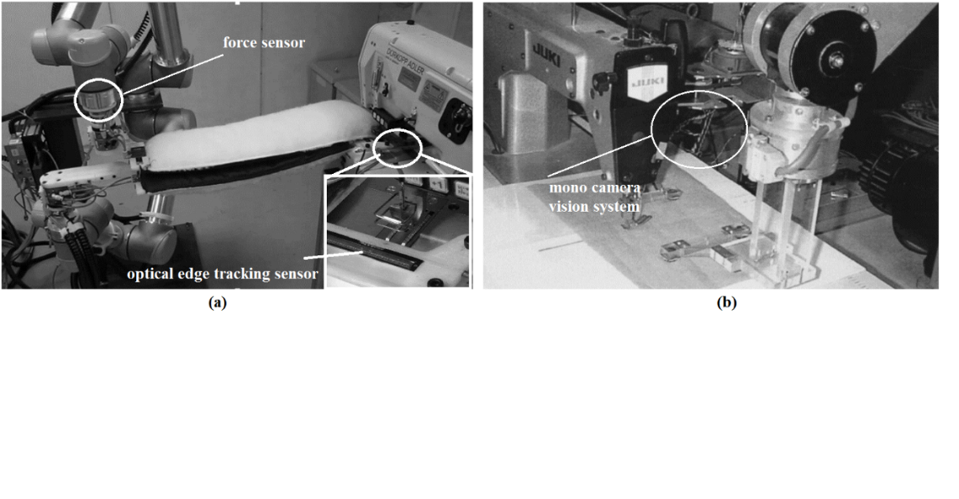

Fig. 2.5 Dual-arm sewing system: (a) Schrimpf et al. [2] (b) Kudo et al. [9]

robot must simultaneously exert force in the direction orthogonal to the fabric feeding direction. Different with controlling the two robotic arms as a whole, a leader/follower control strategy was proposed by Schrimpf et al. [12]. In their work, the robot assigned to be the leader is controlled using the edge and force controllers. The other robot assigned as follower is controlled with the edge controller and a distance coordination controller which seeks to achieve coordinated gripper-to-needle distance with the leader.

To date, the focus of on intelligent robotic sewing systems is still on fabric handling and sewing. Even through being called an intelligent sewing robot, it is actually a fabric handling robot working with conventional sewing machine fixed on a table. To move the intelligent sewing technique from 2D to 3D, research merely on tension control and visual tracking is not enough, more work on robot planning, control and multi robots cooperation needs to be done.

**4 Literature review on Surgical Suturing**

4.1 Surgical Stitching and Knotting types

Suturing is used to hold together tissue gap after an injury or surgery is made. To prevent damaging tissue, a circular needle which could reduce the tissue deformation is more often used. A needle driver is used for holding the needle effectively. The most commonly applied stitch types are running stitch, blanket stitch and mattress stitch (Fig. 4.6). To secure the stitches, knots (Fig. 4.7) are made at the beginning and ending of the suturing. In extreme cases, knots are made right after every stitch.

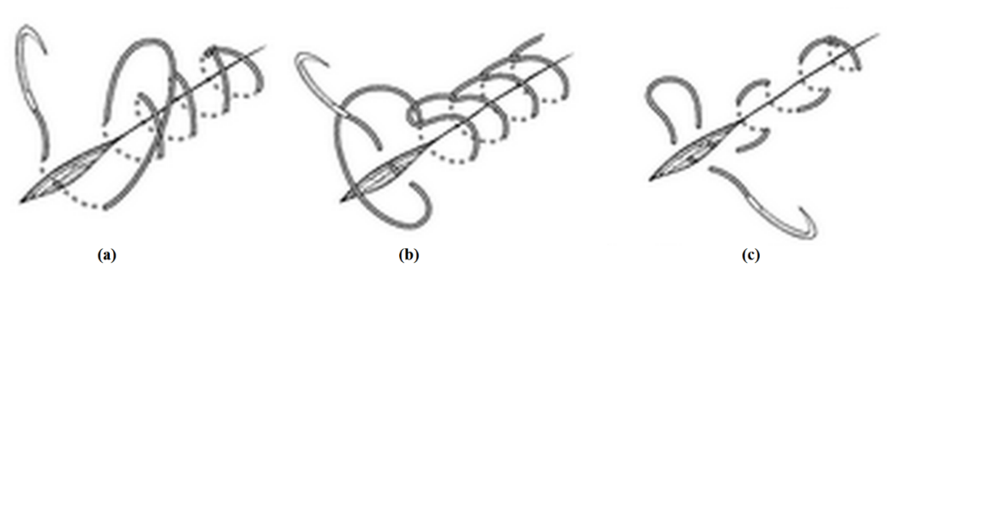

Fig. 4.6 Surgical Stitching types: (a) Running suture (b) Blanket suture (c)Mattress suture

From Dorland , 2000. [64]

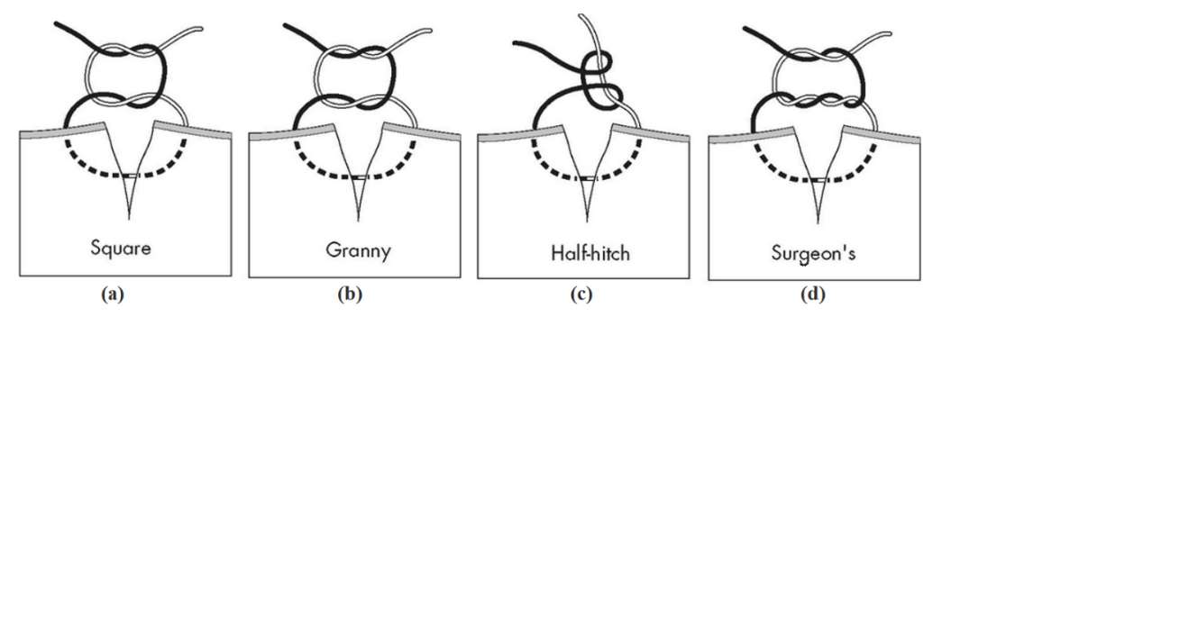

Fig. 4.7 Surgical knots types (From Mosby, 2001 [63])

Techniques for performing surgical knot tying are various, but the most widely used is the surgeon’s knot (Fig. 4.8) in which a loop is made by holding the suturing needle end with one grasper to wind the thread around the other grasper which is holding the thread end. Then, a

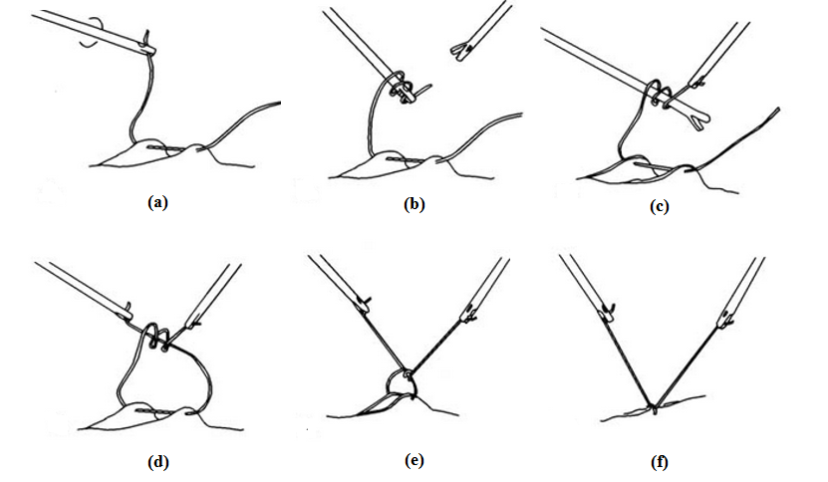

Fig. 4.8 Surgeon’s knot, (From Sanfilippo JS and Levine RL [62])

knot is made by picking the thread end through the loop and pulling both ends till the thread is tight.

**4.2 Assistant Suturing Device**

Intracorporeal suturing is probably one of the most difficult tasks, which can complicate, prolong or preclude the performing of minimally invasive surgical procedures. To alleviate surgeon’s burden, a series of devices are designed to assist performing intracorporeal suturing. A suturing task can be divided into two sub-tasks: tissue piercing and knot tying. For the tissue piercing, most importantly, the surgeon needs to guarantee a minimal damage to the tissue when driving the needle, while in the knot tying sub-task limited intracorporeal space and constrained degree of freedom is the major constraint.

Most of the tissue piercing assistant devices are designed with dexterous mechanisms able to drive a suturing needle to do tissue piercing; the job left for the surgeon is to merely position the device on the target position and trigger the needle driving mechanism. A commercial available laparoscopic suturing device is the SILS™ Stitch instrument (Covidien Ltd, Ireland) [15], which performs stitching by passing a straight needle between two grasper jaws. Endo360º suture tool (EndoEvolution, LLC, Raynham, USA) [16] is another device for the same purpose. It features a mechanism that drives a circular suture around its centre axis. Similar suturing devices using circular needles include Sutrue® (Essex, UK) [20], SafeStitch Medical Gastroplasty System (Legner et al. 2014)[18] for conducting suturing in gastroesophageal junction, Capio™ SLIM Suture Capturing Device (Boston Scientific Ltd, Boston, USA)[19] and the device invented by Stefanchik, et al. [52]. Different with continuous rotating a circular needle, some devices using curved needles are designed with special mechanism to pass thread from one side of the tissue to another side, for example, OverStitch™ (Apollo Endosurgery Inc, Austin, USA)[17] and the device patented by Janome Sewing Mchine Co. Ltd. [53] with customized needle driver to do lock stitch.

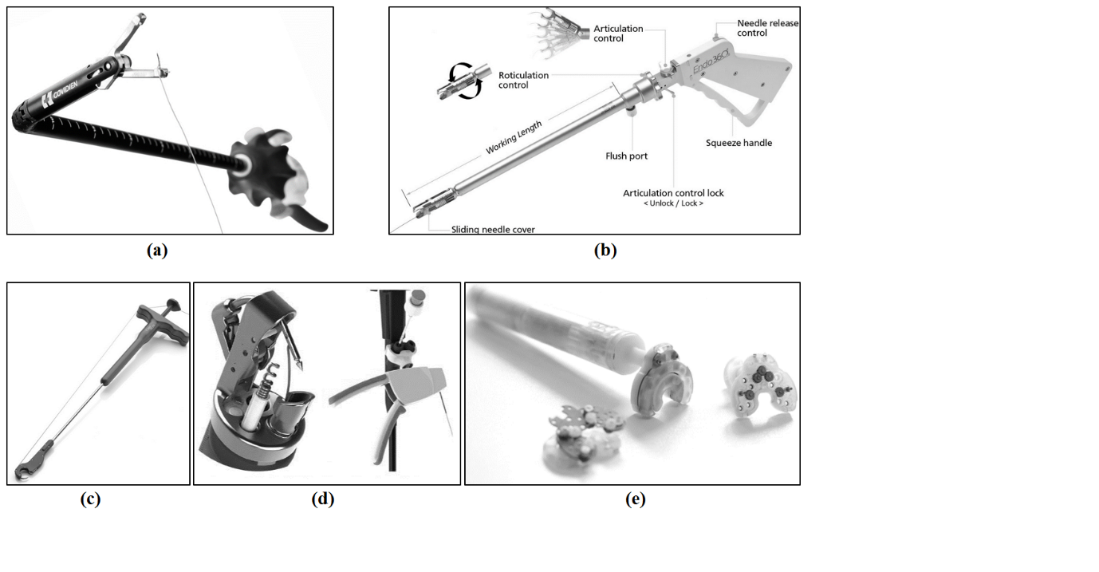

Fig. 4. 3 Assistant Suturing Devices: (a)[SILS™ Stitch Articulating Suturing Device(Photo: Covidien](http://www.covidien.com/surgical/products/single-incision-laparoscopic-surgery/sils-stitch" \t "_blank) Ltd.) (b) [Endo360° suturing devices](http://endoevolution.com/endo360/) (Photo: EndoEvolution LLC.) (c) [Capio™ SLIM Suture Capturing Device (Photo: Boston Scientific](http://www.bostonscientific.com/en-US/products/pelvic-floor-reconstruction/capio-slim.html) Ltd) (d) [OverStitch endoscopic suturing device (Photo: Apollo Endosurgery](http://apolloendo.com/products/overstitch/) Inc.)

(e) Sutrue® automated surgical suturing device (Photo: Sutrue Ltd)

With the use of some suturing assistant devices, complex knot tying procedure has also been made easier. As shown in the demonstration videos released by Covidien [15] and EndoEvolution [16], using either device, knot tying becomes very easy. There are also other devices developed specially for knot tying. For example, a device was developed to tie surgical knot by simply picking the needle end and put it into a loop making mechanism (Jernigan et al. 2010 [21]). And there are some other systems which could deploy pre-tied knots, for example, the Suture Assist (Ethicon Endo-Surgery, [Ohio](https://en.wikipedia.org/wiki/Cincinnati,_Ohio), USA) [22], the Quik-Stitch™ system (Pare Surgical Inc, Colorado, USA) [31]. In addition, a small 3D printed fixture (Bell et al. 2008) called knot box is also very promising to simplify surgical knot tying. Using this fixture, complex movement for knot tying is not necessary; a knot can be easily made by inserting the thread into the fixture’s tunnel and taken out afterwards.

The invention of these devices greatly increases knot tying speed and quality; however all of them require cutting off the suture wire and reloading the suture for making a new knot. The cutting and reloading may take unacceptable long time, which make these devices not suitable for the situation where a larger of thread is needed for banding two objects.

**4.3 Robotic Assisted Suturing and Automated Suturing**

Robotic systems have been widely introduced into minimally invasive surgery in the last decades. Compared with other minimally invasive surgery approaches, robot-assisted surgery gives the surgeon better control over the surgical instruments and a better view of the surgical site. They no longer have to stand throughout the surgery and do not tire quickly. In addition, naturally occurring hand tremors are filtered out mechanically or digitally by using these robots.

While so-called surgical robots have been introduced for decades, they are really not robots at all, but rather remotely controlled machines that faithfully execute the surgeons’ command. To better exploit the machine’s accuracy and speed, it is desired to assign the robots to deal with some routine and repetitive tasks under surgeons’ supervision. Suturing, for example, is an important yet time-consuming part of robotically assisted surgical procedure (Fig. 4.4), which has the potential being automated in future’s surgery.

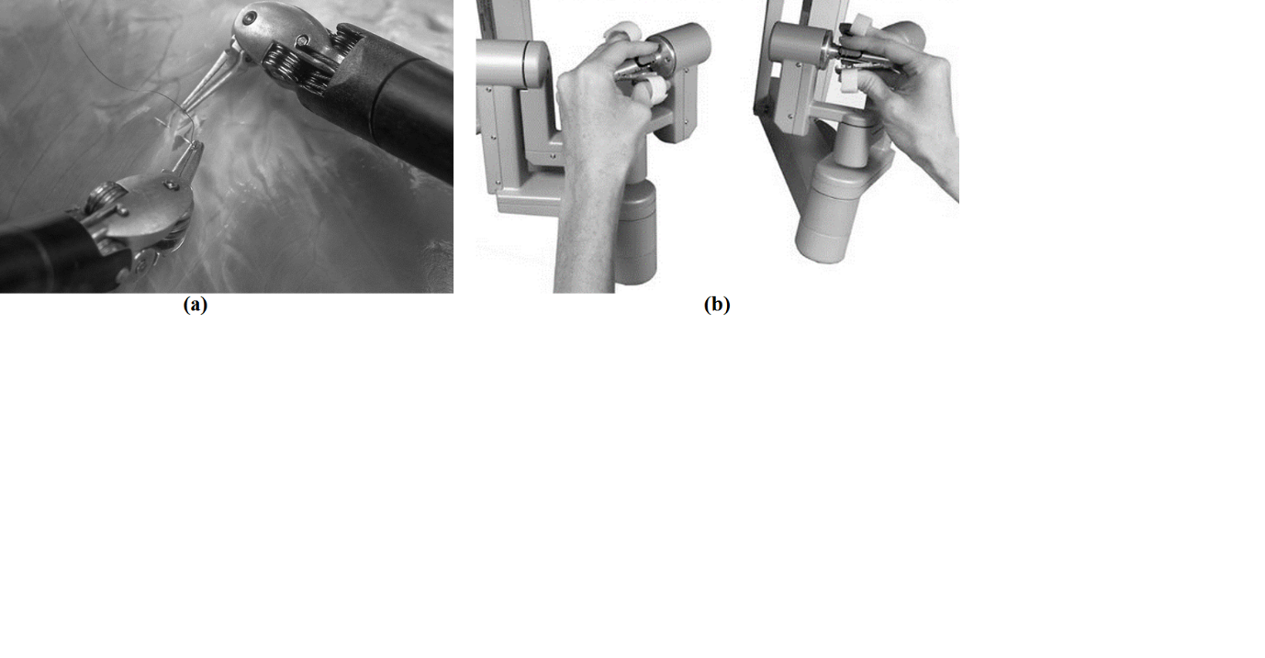

Fig.4.4 Robotic assisted [laparoscopic](https://www.google.co.uk/search?newwindow=1&es_sm=93&q=laparoscopic&spell=1&sa=X&ved=0CBsQvwUoAGoVChMIr_Lf5LS_xwIVokvbCh0V_gty) suturing (Photo: Intuitive Surgical Inc).

**4.3.1 Tissue Piercing**

Well established manual suture techniques lay the foundation for robotic suturing. In order to pre-plan the suturing for later automation, the general rules that surgeons use to complete a suture in open surgery are studied (Jackson et al., 2013) [23]:

1. To reduce tissue damages, the needle is preferred to “bites” the tissue orthogonally at the entrance point.
2. Minimize stress caused on the tissue when driving the needle from the entrance point to the exit point.
3. At the entrance point, the re-grippable length of the needle should be adequate for regrasping.

A full constraint suturing approach was taken in the work presented by Kapoor et al. 2008 [24], in which the ideal suturing path is a circular path following the needle body. Even through this approach obviously minimizes tissue deformation during stitching, it is impossible to drive the needle to any exit point or select the suturing depth once the needle enters the tissue. A less conservative suturing planning was present by [23]. In their work the entrance and exit point are fixed and tissue deformation are minimized. Two needle trajectories for driving the needle from the entrance point to the exit point were presented (Fig. 4.5). In the first trajectory, the needle is reoriented around a fixed point, for example, the entrance point, to minimize the overall tissue trauma. In the second trajectory, the needle tip is selected to go along its tangent direction to avoid having the needle tip tear laterally. In another work, Nageotte et al. 2005 [25], 2009 [26], modelled the [laparoscopic](https://www.google.co.uk/search?newwindow=1&q=laparoscopic&spell=1&sa=X&ved=0CBsQvwUoAGoVChMI3LTdtLfFxwIVBtgaCh1NJwsk) suturing task as a constraint optimization problem. Besides consider the allowable maximum tissue deformation, their approach takes one step future to consider the kinematic constraints created by using four-degree-of-freedom needle holders inserted through a fixed point in the abdominal wall of the patient. Using the A\* algorithm, an optimized trajectory was found between the entrance and the exit point. Ding et al. 2014 [56] tried to define the minimal constraint in suturing task and used it to guide the selection of handedness during robot suturing. Tissue defamation is another factor should not be omitted during suturing. Some research are tried to quantify and therefore minimize it. For example, in the work (Khabbaz et al. 2011), finite element models is introduced for modelling the tissue needle interaction and an optimized needle trajectory was obtained using this model. Besides path planning method, learning from human demonstration is another way to encode the stitching skills, for example, Hager et al., 2011 [2] using the Hidden Makov Model (HMM) to encode human demonstrated suturing trajectories.

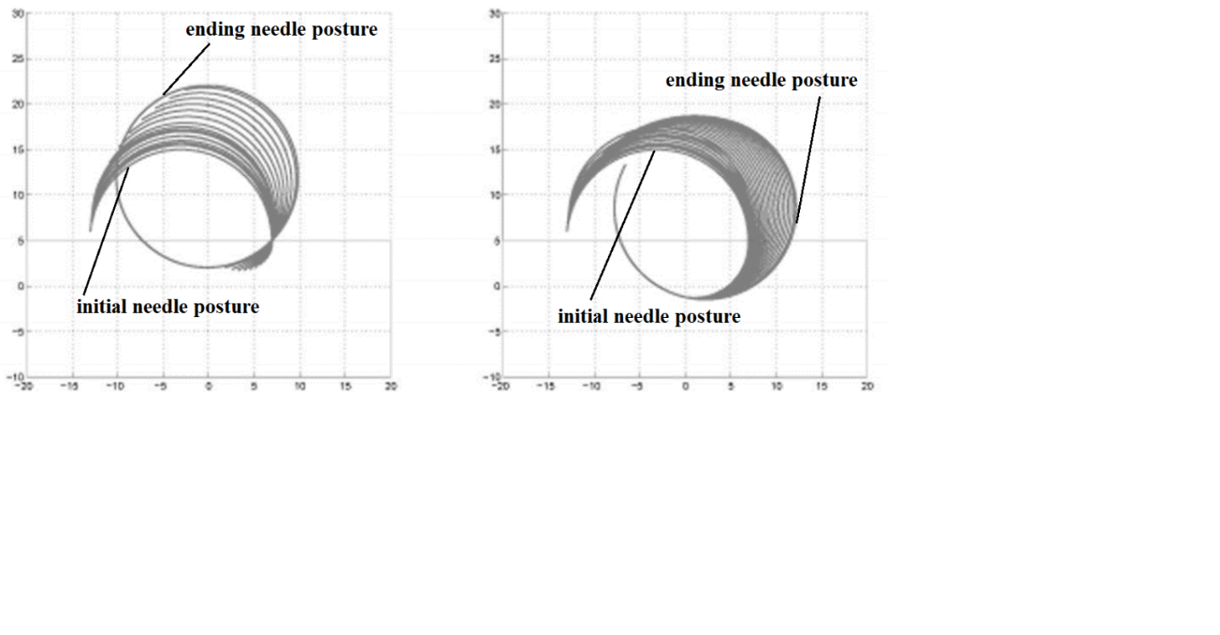

Fig.4.5 Time lapse plots for needle trajectories from the entrance to exit point (Jackson et al. 2013 [23])

(a) Needle reoriented around the entrance point. (b) Needle goes tangent to its tip.

**4.3.2 Knot Tying**

knot tying is another important part of suturing. In laparoscopic or endoscopic surgery, knot tying requires using more than two needle graspers. Compared with tissue piercing, knot tying is relatively less demanding on planning and control accuracy; however, to automate knot tying, the need for regrasping suture renders a great challenge. Initial works on automated knot tying use a hard-wired policy, meaning that it always repeats the same pre-defined motion. These works perform either by hard coding the instruments’ trajectories (Chow el at., 2011 [27]) or recording these trajectories from human demonstration (Nagy et al., 2004 [28]). Later, machine learning techniques are introduced for the purpose of adapting the knot tying skills to unmet situation, Mayer et al. (2008 [29]) used recurrent neural networks to unfamiliar instrument locations. Murili et al. (2015 [55]) explored Learning by Observation approach which can identify, segment, and parameterize motion sequences to build a finite state machine (FSM) for each subtask in robotic surgery. Van Den Berg et al. (2010 [30]) used iterative learning control to improve the knot tying speed and accuracy. Schulman et al. [42] implemented a method which uses Non-Rigid Registration for generalizing knot tying skills. Osa et al. (2014 [43]) proposed an online planning method which could make the knot tying trajectories adapt to uncertain surgical instrument movement. Thread tension control is another important topic in automated knot tying. To finish a knot, the thread needs to be pulled properly in order to secure it. For this purpose, various methods have been developed, include the work using force/torque measurement sensor (Kang et al. 2012 [59]), the work which calculates the proper pulling length using the thread’s intrinsic material property (Wang et al. 2008 [60]) and the method using visual information to measure the thread’s tension (Martell et al. 2011 [58]).

**4.3.3 Visual Guidance**

Even though it is arguable that tissue piercing can be programmed by using merely hardwired policy, positioning the needle on the suture point with correct posture, regrasping the need either for finish one stitch or perform knot typing, vision is an unavoidable part.

In the aspect of positioning the needle to the target point, both the needle posture and the target suturing plane posture need to be measured. Iyer et al. 2013 [44] proposed a single arm single camera system auto-suturing system in which the area being sutured on is marked by round markers. With the known geometry of the circular needle and the round marker, the monocular pose measurement algorithm proposed by De Ipna et al. (2002 [47]) was used for estimating the needle and tissue posture. Another work presented by Staub et al. (2010 [45]) introduced 3D stereo system and visual servoing technique to improve the accuracy in aligning the needle with target stitching point. Recently, an auto-suturing system with 2D camera guidance and motorized Endo 360º suturing device is presented (Leonard et al. 2014 [46]). In this work, a method is presented to track incision contour and automatically distributes equally-spaced stitches along the incision.

For needle regrasping, according to the author’s review, there are no effective vision guided methods proposed at current stage. Needle regrasping task requires measuring both the needle and needle driver’s posture. On one hand, estimating needle posture is especially difficult when the needle is inside the area being sutured. Perhaps this can be solved with model based 3D registration algorithm plus prior knowledge on the needle’s trajectory or posture. On the other hand, measuring the needle driver’s posture seems easy, because it is readily obtained from the robot holding it. However, for tendon driven surgical robotic system with huge backlash, its accuracy is in doubt. With vision system, more robust method instrument posture measurement could be achieved. For example, Pratt et al. (2015 [48]) attached KeyDot® tracking marker (KeySurgical Inc., Eden Prairie, USA) on the instrument to help estimate the instrument’s posture, while Reiter et al. (2013 [49]) recovered the tool’s posture using its low-level landmark features.

5 Multi-Robots Stent **Graft** **Sewing** Experiment

As reviewed in chapter 2, the available sewing machines are not able to sew on fenestrated/branched stent grafts with complex geometrical shapes. Hand sewed stitch is still a better solution than machine made stitch in term of elegancy and strength. Due to this fact, we decide to transfer human sewing skills directly to a multi-arm robotic system which is able to perform bimanual sewing. A system with three articulated robots are built (Fig. 5.1): two robots each mounted with motorized needle driver and a third robot for holding a mandrel with a stent graft. 10mm circular suturing needle is used for performing the sewing task. One potential of this system is that it is versatile to deal with various stitching types and even make knots. In the following of this charter, the control frame work of this system is presented, which largely comes from the author’s research on task priority co-operative control (Hu et al. 2015).

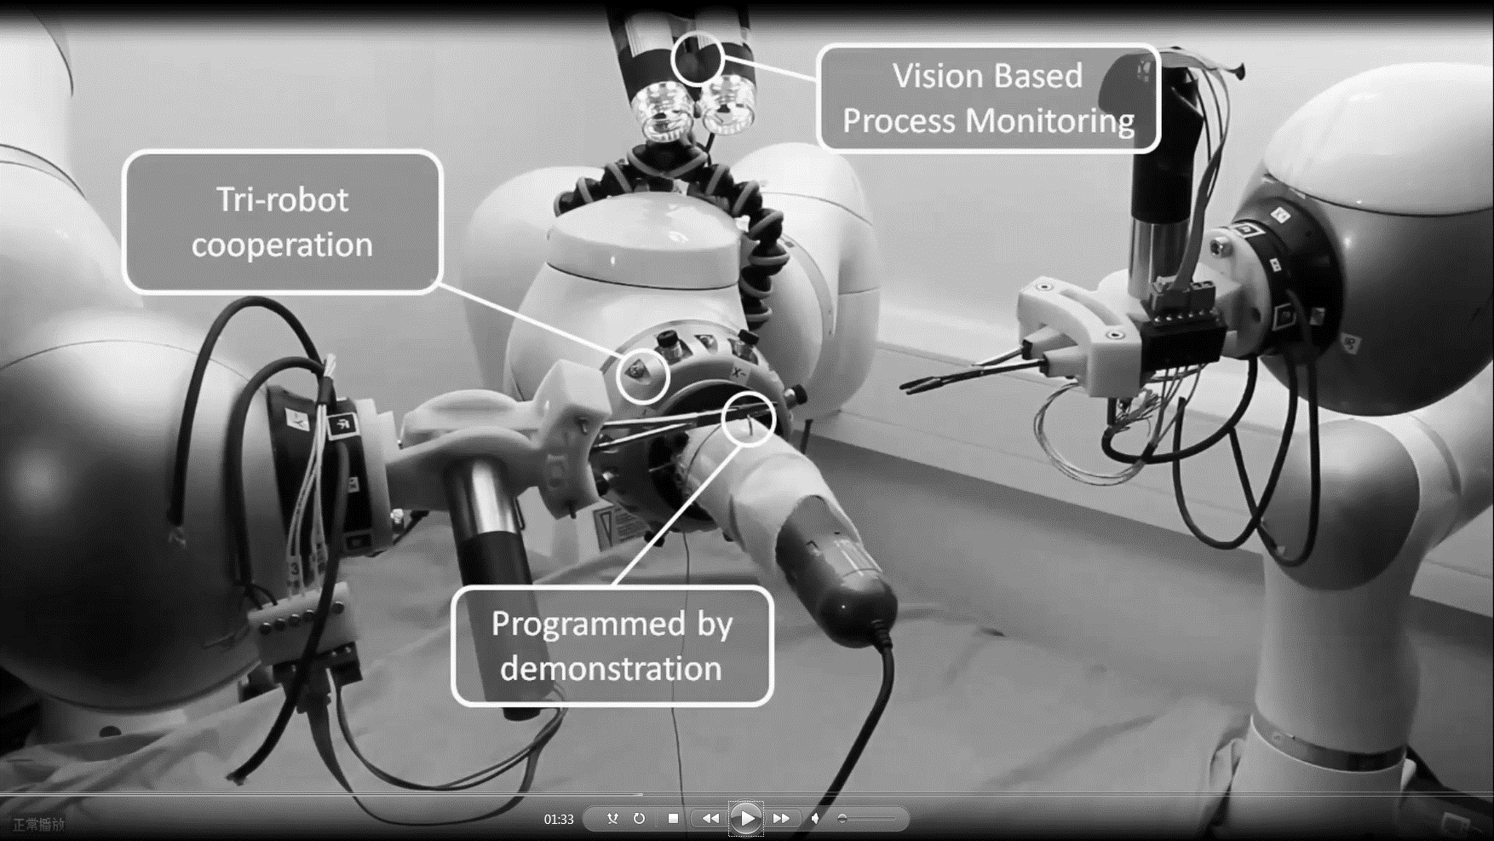

Fig. 5.1 Multiple Robotic Stent Graft Sewing

**5.1 Co-operative Robots Motion Planning/Control**

A fundamental problem with dual-arm robotic control is to find the coordinated motion resolution under high kinematic redundancy and intrinsic constraints of each robot. To solve this problem, this paper presents a multi-tasking, co-operative control framework, in which potential task conflicts and robot joint constraints are properly handled. Based on the relative Jacobian formulation, singularity-robust inverse kinematics and the scheme of null space distributing exceeded joint velocity, this work contributes by introducing a framework to handle multi-tasking conflicts both in task and joint space for dual-arm robots.

**5.1.1 The Relative Jacobian**

For two arms performing a co-operative task of object manipulation, we define the object holding arm as the workpiece robot $W$ and the tool holding arm as the tool robot $T$. The base and end-effector frames of the $W$ are denoted as ${ F}_{1}$ and ${ F}_{2}$ respectively; while for the $T$ they are represented as ${ F}_{4}$ and ${ F}_{3} (Fig.5.2)$. With a coordinate transformation, the position and orientation of the tool can be transferred into the end-effector frame of the $W$. A task can therefore be assigned by defining the 6-dof movement of the tool related with the workpiece.

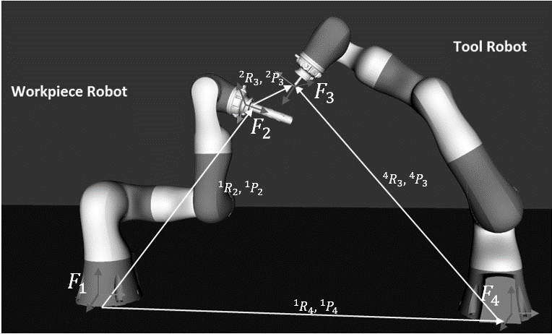

Fig. 5.2. Schematic illustration of the coordinate frames used for the dual-arm system

This relative movement can be further mapped into the joint space of each robot by a pseudo inverse of the relative Jacobian proposed in a previous work [32]. The relative Jacobian refers as a mapping of joint variable $\dot{q}={[{{\dot{q}}_{W}}^{T} {{\dot{q}}_{T}}^{T}]}^{T}$ to 6-dof task variable ${\dot{x}}_{r}$, as Eq. (1).

|  |  |  |
| --- | --- | --- |
|  | $${\dot{x}}_{r}=J_{r}\dot{q}$$ | (1) |

where ${\dot{q}}_{W}$ and ${\dot{q}}_{T}$ are joint velocity for the workpiece and tool robot, and ${ J}_{r}∈R^{m_{r}×(n_{T}+n_{R})}$ is the relative Jacobian Matrixwhich is expressed as:

|  |  |  |
| --- | --- | --- |
|  | $$\left[\left[\begin{matrix}I & -S\left({}_{ }^{2}{p_{3}}\right) \\ 0 & I\end{matrix}\right]\left[\begin{matrix}-{}_{ }^{2}{R_{1}} & 0 \\ 0 & -{}_{ }^{2}{R_{1}}\end{matrix}\right]\left[\begin{matrix}J_{pW} \\ J_{oW}\end{matrix}\right] \left[\begin{matrix}{}_{ }^{2}{R_{4}} & 0 \\ 0 & {}_{ }^{2}{R_{4}}\end{matrix}\right]\left[\begin{matrix}J_{pT} \\ J_{oT}\end{matrix}\right]\right]$$ | (2) |

In the above formulation, ${}_{ }^{B}{R_{A}}$ represents rotation from frame A to frame B. $S(∙)$ is the skew-symmetric operator with the positional relationship ${}_{ }^{2}{p_{3}}$ as input. This formulation shows that the relative Jacobian is not rank deficient even if one of the individual Jacobian loses ranks. This shows another advantage of treating dual arms as a whole comparing with controlling them individually: the dual-arm robot can work even if one robotic arm becomes singular.

**5.1.2 Prioritized Closed-Loop Inverse Kinematic Control**

In order to solve the algorithm singularity, a damped least-squares inverse with numerical filtering for secondary task is often used when task conflicts occur. Due to the difficulty in tuning damping parameters, Chiacchio et al. [33] proposed a singularity-robust approach, in which the solution of the lower task is directly projected on the null space of the higher one. As a consequence, task conflicts are solved with solution meeting the requirements of the higher priority task rather than the lower priority task, which means the lower priority task tends to have big error. With the closed-loop inverse kinematics implemented for each task, the error in the lower priority task could be reduced gradually through iteration. Gianluca showed how to select feedback gains for a prioritized closed-loop inverse kinematic control using the singularity-robust method [34]. The differential inverse kinematic equation for three prioritized tasks ${\dot{ x}}_{A} {\dot{x}}_{B} {\dot{x}}_{C}$ can be expressed as:

|  |  |  |
| --- | --- | --- |
|  | $${\dot{q}}_{des}=J_{A}^{†}{\dot{x}}_{A}{+N}_{A}J_{B}^{†}{\dot{x}}_{B}{+N}_{AB}J_{C}^{†}{\dot{x}}_{C}$$ | (3) |

where $J_{*}^{†}(*=A,B,C)$ is the pseudo inverse of task Jacobian, and $N_{*}=(I-J_{*}^{†}J_{*})$ is the null space projector, where is $I$ an identical matrix. The third task is projected into the combined null space of $J_{A}$ and ${ J}_{B}$, as,

|  |  |  |
| --- | --- | --- |
|  | $$J_{AB}=\left[\begin{matrix}J_{A} \\ J_{B}\end{matrix}\right],$$ $$N_{AB}=\left(I_{n}- J_{AB }^{†}J_{AB}\right)$$ | (4) |

To increase control accuracy under system dynamics, a closed-loop control strategy (Eq. 5) is implemented by adding a feedback term related to task error $\tilde{x}$, which equals the desired pose $x_{d}$ minus by the actual pose $x_{ }$.

|  |  |  |
| --- | --- | --- |
|  | $${\dot{x}}_{ }={\dot{x}}_{d}+Λ\tilde{x},$$ $$\tilde{x}=\left(x_{d}-{x_{ }}_{ }\right)$$ | (5) |

where $Λ$ is the feedback gain.

The orientation part of task error ${\tilde{x}}_{o}$ is preferred to be calculated by using quaternions in order to avoid the representation singularity of using the Euler angle [35]. The orientation error is calculated with the desired orientation $ϱ_{d}=\{η_{d}, ϵ_{d}\}$ and actual orientation ${ ϱ}_{ }=\left\{η_{ }, ϵ_{ }\right\},$ as Eq. (6), in which $η$ is the scalar part and $ϵ{=[ϵ_{x} ϵ_{y} ϵ_{z}]}^{T}$ is the vector part,

|  |  |  |
| --- | --- | --- |
|  | $${\tilde{x}}_{o}=η_{ }ϵ_{d}-η_{d}ϵ_{ }-S(ϵ_{d})ϵ_{ }$$ | (6) |

where the skew-symmetric operator $S (∙)$ is used to replace cross product.

**5.1.3 Preserving Task-Priority under Joint Limits**

The singularity-robust method removes algorithm singularity caused by task conflicts. If the sole Jacobian of the primary task is non-singular, the whole system is non-singular. However, the solution given by this method does not consider the true capacity of each robot; if a joint encounters position or velocity limits, being kept its saturation value, the trajectory executed by the end-effector would be deviated. Further, joint limits violation may also ruin task priority. In some situations, even if a high priority task is executable, joint saturation may still be caused by a low priority task. This situation is not acceptable in the task-priority framework.

A conventional method for handling joint range limits is to distribute the exceeded joint velocity in Jacobian null space. By locking the joint which would violate its limit and zeroing the corresponding Jacobian column, the saturated joint is removed from inverse kinematic calculation [36]. The Saturation in Null Space algorithm [37] takes one step further by only handling the most saturated joint, which shows a reduction of the joint velocity norm in null space distribution. In addition, task scaling factors are used when joint limits violation is inevitable.

First, assume the boundaries on joint velocity and range are symetrical, respectivly $V^{bound}$, $Q^{bound}$. The saturation bound on joint position and velcotiy are:

|  |  |  |
| --- | --- | --- |
|  | $${-Q}^{bound}<q<Q^{bound},$$ $$-V^{bound}<\dot{q}<V^{bould}$$ | (7) |

The volocity boundary should be modfied near joint range limits. In a digital control implememtation with samling time $T$, the joint velocity in step $k$ is kept as contant until next step. It is required that the joint limits in $k+1$ is not voilated, and thus,

|  |  |  |
| --- | --- | --- |
|  | $${{-Q}^{bound}<q}_{k}{+\dot{q}}_{k}T<{-Q}^{bound}$$ | (8) |

Then upper and lower limits for the velocity of joint $i$ can be express as below:

|  |  |  |
| --- | --- | --- |
|  | ${\dot{Q}}_{i}^{min}=max \{ \frac{{-Q}_{i}^{bound}-q_{k,i}}{T}, {-\dot{V}}_{i}^{bound}$}, $${\dot{Q}}_{i}^{max}=min \{ \frac{Q_{i}^{bound}-q_{k,i}}{T}, { \dot{V}}_{i}^{bound}\}$$ | (9) |

Finally the boundary for all joints are obtained as:

|  |  |  |
| --- | --- | --- |
|  | ${\dot{Q}}_{ }^{bound}=$ [${\dot{Q}}_{ }^{min}, {\dot{Q}}_{ }^{max}$] | (10) |

In each control loop, the joint velocity boudary ${\dot{Q}}_{ }^{bound}$ for the next step will be predicted based on current joint position. If the desired joint velocity ${\dot{q}}_{des}$ voilates this boundary, null space distributing of the exceeded joint volocity is performed as below.

Firstly, the contribution from the exceeded i-th joint ${\dot{Q}}_{i}^{bound}$ is deducted from the Cartesian task $\dot{x}$, and its corresponding column $J_{i }$ in task Jacobian ${ J}_{ }$ is set to zero. Secondely, the remaining part of task $\dot{x}$ are distributed to the unsaturated joints with minimal norm using the pseudo inverse of $J$**.**  Finally, the contribution from the saturated joints is added back with their saturation values. The following Eq. (11) expresses the above idea. In this equation, an auxiliary diagonal matrix $W_{A}∈R^{n×n}$ is used for zeroing certain columns of $J$. It has zeroes corresponding to the saturated joints and ones corresponding to the unsaturated joints. In addition, a vector ${\dot{Q}}_{s}∈R^{n}$ is used in order to keep the corresponding joint saturation value. Initially, $W_{A}$ is set as identity matrix and ${\dot{ Q}}_{s}$ is set as **0**.

|  |  |  |
| --- | --- | --- |
|  | ${\dot{q}}_{new }^{ }={({W_{A}}_{ }J_{ })}^{†}(\dot{x}-J_{ }{\dot{Q}}_{s})$ + ${\dot{Q}}_{s}$ | (11) |

Eq. (11) runs as an inner loop within kinematic control for checking joint limits violation. The loop terminates when a ${\dot{q}}_{new }^{ }$ within joint velocity boundary is found or the rank $J$ is less than the dimension of task $\dot{x}$. In the latter case, $J$ becomes singular and the joints left unsaturated are not enough to realize the Cartesian task $\dot{x}.$

The above algorithm is designed for single task applications. In this paper, we propose a strategy for extending the algorithm to task-priority framework for dual-arm robot using relative Jacobian. In order to handle joint limits in a hierarchical order, it requires the joint capacity to be used by a higher task first. If joint limits are violated, the exceeded joint velocity is first distributed to the composite Jacobian null space of all the tasks. If the composite Jacobian becomes rank deficient and joint saturation still remains, the lowest level task is taken out of the composite Jacobian stack, which means its performance is sacrificed for preserving all higher level tasks. This process stops until the rank of the composite Jacobian is less than the primary task.

The proposed joint limits handling strategy constantly observes the value ${\dot{q}}_{des}$ as defined in Eq. (3), and simultaneously updates the joint velocity boundary ${\dot{Q}}_{ }^{bound}.$ For a 3-task case, the parameters used in Eq. (11) are initialized as:

|  |  |  |
| --- | --- | --- |
|  | $W=I$**, $Q_{S}=0$, $$J_{ }=\left[\begin{aligned}\begin{matrix}J_{A} \\ J_{B}\end{matrix} \\ J_{C}\end{aligned}\right]{∈R}^{(m_{A}+m_{B}+m_{C})×n}$$ $$\dot{x}=\left[\begin{aligned}\begin{matrix}{\dot{x}}_{A} \\ {\dot{x}}_{B}\end{matrix} \\ {\dot{x}}_{C}\end{aligned}\right]{∈R}^{m_{A}+m_{B}+m_{C}}$$** |  |

The algorithm enters a loop which stops until a ${\dot{q}}_{new }^{ }$ within ${\dot{Q}}_{ }^{bound}$ is found. The ${\dot{q}}_{new }^{ }$ is then sent to the robot controller. If the rank of $J$ is less than the dimension of $\dot{x}$, then the lowest task $J_{C}$ and ${\dot{x}}_{C}$ are removed from Eq. (11) and the loop continues. By removing the lowest task, the new optimization loop steps into a bigger null space for searching qualified joint command values. This process continues until the primary task is sacrificed, which means a reconfiguration of joint position is needed. It is worth noting that once ${\dot{Q}}_{ }^{bound}$ is no longer violated by ${ \dot{q}}_{des}$, the tasks should be recovered with priority high to low.

**5.2 Simulation Study**

Detailed simulation studies have been conducted using the kinematic model of Kuka LBR iiwa 820 robot. Its Denavit-Hartenberg parameters (Table. I) are derived according to the Kuka manual [38]. The world frame is aligned with the base frame of the workpiece robot W. In the world frame, the tool robot T rotates ${180}^{∘}$ around z direction, and translates 1.4m along the negative direction of y axis. Sampling time for closed-loop inverse kinematic is set to be 0.002s. Using the simulated dual-arm robot, two studies have been taken. In the first study, task conflicts solved by the prioritized singularity-robust method is presented. The second study shows that the proposed framework preserves task priority under joint constraints.

1. Denavit–Hartenberg parematers

| i | $α_{i-1}$ (rad) | $a_{i-1}$ (m) | $d_{i}$ (m) | $θ_{i}$ (rad) |
| --- | --- | --- | --- | --- |
| 1 | 0 | 0 | 0.360 | 0 |
| 2 | $π$/2 | 0 | 0 | 0 |
| 3 | - $π$/2 | 0 | 0.420 | 0 |
| 4 | - $π$/2 | 0 | 0 | 0 |
| 5 | $π$/2 | 0 | 0.400 | 0 |
| 6 | $π$/2 | 0 | 0 | 0 |
| 7 | - $π$/2 | 0 | 0.188 | 0 |

**5.2.1 Simulation Study 1 (Task Conflicts Handling)**

In this study, the end-effector of the workpiece robot is holding a cylindrical object. The tool robot is holding a needle-like tool (Fig. 5.2). The initial joint positions for the workpiece and tool robot are set as $q_{W}=$ [90 -90 0 -90 0 -90 0] $^{T}$ (deg) and $q_{T}=$ [90 -50 0 50 0 100 0](deg) respectively. In this study, the task-priority singular-robust inverse kinematics method is compared with the composite Jacobian inverse kinematic method in two situations: 1) the primary and the secondary task conflict; 2) no conflict.. In the conflicting case, the primary task ${\dot{x}}_{A}$ is to ask the tool to rotate around the central axis of the cylindrical workpiece with a speed of $24$ degree/s. At the same time, the tip of the tool should always point to the radial direction of the cylinder and touch on the outer surface on the cylinder. The secondary task ${\dot{x}}_{B}$ is assigned as keeping position and orientation of the workpiece holding arm constant. In this case, the Jacobian of the primary task is ${ J}_{r}∈R^{6×(14)}$, while the second task Jacobian is $J_{B}=\left[\begin{matrix}J_{w} & 0\end{matrix}\right]∈R^{6×(14)}$. Tasks conflict in this situation as the tool robot will reach the boundry of its workspace when rotating around the workpiece robot if the workpiece robot is static. In the non-conflicting case, the requirement for the secondary task is same as the conflicting case; while the orientation constraint of the primary task is relaxed by only requiring the end-effector of tool robot circle around the central axis of the cylinder. The singular-robust inverse kinematics and the composite Jacobian inverse kinematic are expressed as Eq. (12) and (13).

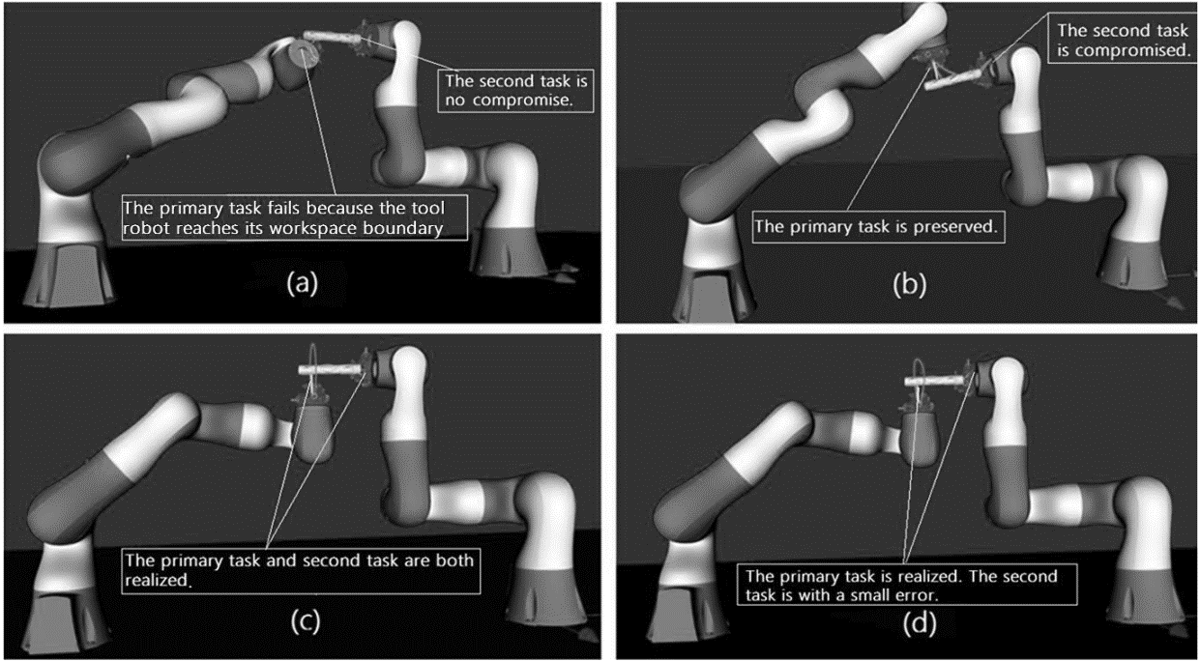

Fig. 5.3 (a) Tasks conflicting case with composite Jacobian Method. (b) Tasks conflicting case with task-priority singularity-robust method. (c) non-conflicting case with composite Jacobian Method. (d) non-conflicting case with task-priority singularity-robust method.

Feedback gains ${ Λ}_{A}=60$ and ${ Λ}_{B}=10$ are used in both method.

|  |  |  |
| --- | --- | --- |
|  | $${\dot{q}}_{des}=J_{r}^{†}{\dot{x}}_{A}{+(I-J_{r}^{†}J}_{r}){\left[\begin{matrix}J_{w} & 0\end{matrix}\right]}^{†}{\dot{x}}_{B}$$ $${\dot{q}}_{des}=J_{com}^{†}{\dot{x}}_{com}$$ | (12)  (13) |

where ${ J}_{com}=[{\begin{matrix}J_{r}^{T} & J_{B}^{T}\end{matrix}]}^{T}$ and ${\dot{ x}}_{com}^{ }={[\begin{matrix}{\dot{x}}_{A}^{T} & {\dot{x}}_{B}^{T}\end{matrix}]}^{T}$.

The simulation result is presented in Fig. 5.3. In the conflicting task case, the composite Jacobian method Fig. 5.3 (a) fails after the tool robot rotates around the central axis about ${ 24}^{∘}$, a huge increasing in joint velocity stops the simulation. By resorting to the singularity value decomposition method, the lowest singular value of the composite Jacobian is as small as 0.000454. Since both $J_{r}^{ }$ and $J_{B}^{ }$ both have full rank, the decreasing of the lowest singular value is caused by the algorithm singularity that $J_{r}^{ }$ and $J_{B}^{ }$ are becoming linear dependent during task execution. On the contrary the singularity-robust method effectively overcomes the task conflicts. The primary task performs well with negligible error while the secondary task is compromised during task conflict (Fig.5.3 (b)). After analyzing the relationship between the task errors and the lowest singular value of the composite Jacobian ${ J}_{com}$, we have found that using singularity-robust method, the secondary task is compromised the most when the two tasks are becoming dependent (the lowest singular value of the composite Jacobian is approaching zero) (Fig. 5.4), which is a desired feature of the task-priority approach.



Fig. 5.4. Relationship between task error and the lowest singular value of the composite Jacobian

In the non-conflicting case, both methods give negligible task errors for the primary task (Fig. 5.3 (c), Fig. 5.3 (d)), while position and orientation errors for the secondary task are slightly increased by using singularity-robust method. As shown in Fig.5.3 (d), the position and orientation variation of the workpiece makes the tool robot accommodate by deviating from its original circular trajectory. The singularity-robust method inevitably cause error for lower priority tasks because of the null space projection. This error could be reduced using other methods such as variable damping strategy or reverse priority strategy [39, 40]; however, the task-priority singularity-robust method has the advantage of not requiring tuning the complex damping factors.

The task-priority singularity-robust inverse kinematics solves task conflicts at task space; however, the command joint trajectory maybe non-executable. For example, after the tool robot rotates around the cylinder central axis about ${280}^{∘}$, the fifth joint of tool robot exceeds its limit on ${ 170}^{∘}$. Later the limit on the third joint of tool robot is also violated. In simulation study 2, joint limits will be handled according to task priority using the method in section II C.

**5.2.2 Simulation Study 2 (Joint Constraints Handling)**

In this scenario, the method of distributing exceeded joint velocity in null space according to task priority is tested. The limits on joint range and velocity are each selected with $Q^{bound}$ = (160, 160, 160, 160, 160, 160, 160) [degree], $V^{bound}$ = (100, 100, 100, 100, 100, 100, 100) [degree/s]. A sampling time of 0.002s are used in order to predict the velocity bounding box. In addition, to determine when a lowest task needs to be sacrificed, singular value decomposition is used: when the lowest singular value of $J$ is less than 0.01, it is regarded as rank deficiency.

In this simulation, three prioritized tasks are arranged. Primary task A is the desired relative movement of the tool and the workpiece which is exactly same with the first situation in simulation 1; the second task B is to keep the end-effector position of the workpiece robot; the third task C is to prevent the workpieice robot from rolling around the z-axis of its end-effector (constant roll angle) with Jacobian $J_{C}^{ }∈R^{1×(14)}$. It is worth noting that the third task is projected onto the null space of the composite Jacobian null space of task A and B. The feedback gains for task A, B, C are 60, 10 and 5 respectively. In order to demonstrate the effectiveness of the proposed method in preserving task priority when encountering joint limits, a simple strategy of clamping joint at saturation value is used for comparison. In Fig.5.5 (a, c), the error for each task and the joint saturation status using joint clamping method are plotted. Initially with no joint saturation, all errors are small. When joint 7 of the workpiece robot reaches its upper boundary in 8th second, significant errors are presented in all tasks; task-priority is therefore violated. Fig.5.5 (b, d) show the proposed method in preserving task priority.

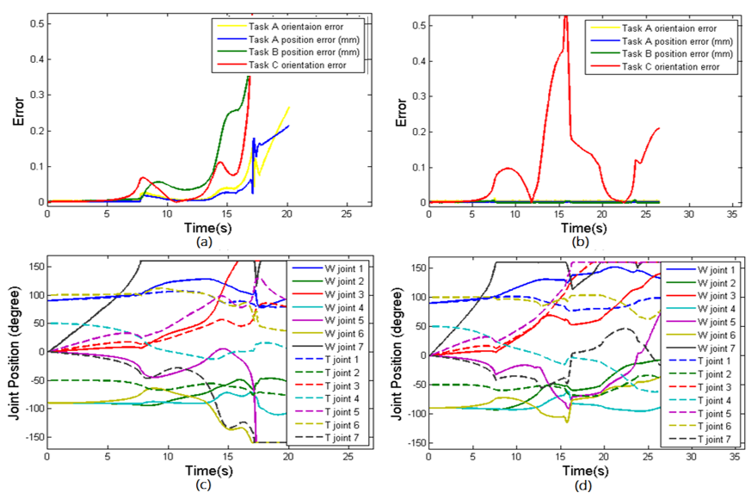

Fig. 5.5. (a) Task errors by joint clamping method. (b) Task errors by the proposed method. (c) Joints saturation status of joint clamping method. (d) Joints saturation status of the proposed method.

Joint saturation in the 8th second only increases the error on the third task, while the primary task is not impacted. Eventually, the primary task fails at 30s, because all the lower level tasks are sacrificed. By then, the tool already rotates around the workpiece more than ${ 700}^{∘}$.

**5.3 Experiment Study for 3-D Stent Graft Sewing Task**

In this experiment study, the proposed co-operative control framework is demonstrated by using a dual-arm system for a stent graft manufacturing task (Fig.5.6). A stent graft is a tubular medical device with sinusoid stents sewn on the surface of graft fabric. Traditionally, the stent graft sewing is conducted by hands. State of the art applications use customized sewing machine with one degree rotation to increase productivity. However, static mounting sewing machine lacks the flexibility to manufacture personalized stent graft with irregular shape. In our proposed method, the stent graft and the sewing machine are each held by one robot arm. The dexterity of using dual arms bestows the capability to sew an irregular shape stent graft.

An important part for the stent graft sewing task is that the stitching needle should be able to continuously follow the planned sewing. When the dual-arm robot is performing such complex movements, joint limits would be violated. In addition, auxiliary tasks are required to constrain the working space of the dual arm robot, for example, avoiding collision with the table. To this end, three tasks are assigned. In the primary task, the sewing needle held by tool robot is tracing the sinusoid sewing trajectory and puncturing the fabric simultaneously. The second auxiliary task is assigned to keep the end-effector position of stent graft holding arm to provide operation stability and at the same time preventing collision with table. In the lowest priority third task, the orientation of the stent graft holding arm is maintained. This is the lowest priority task and can be sacrificed first when joint limits are encountered.

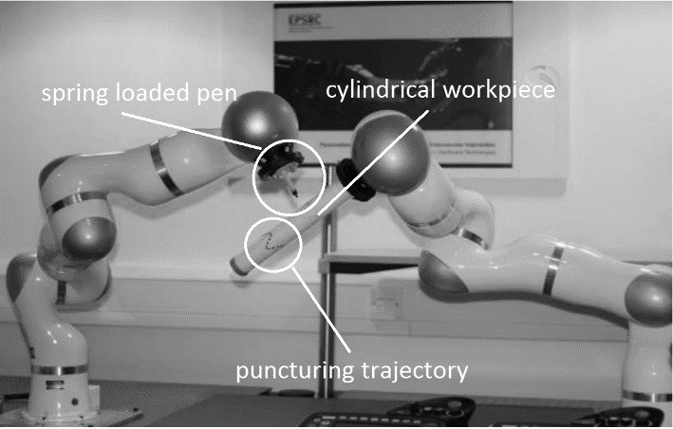

Fig. 5.6 The configuration of dual-arm stent graft sewing

In this initial experiment, the needle is simulated by using a spring loaded pen with black ink, and a paper tube is used for mimicking the graft fabric. The frequency of needle puncturing is 0.5Hz. The experiment set-up are illustrated as Fig.5.6, in which two Kuka LDR 4 robots are set in joint position control scheme using the FRI interface with frequency of 500Hz. The initial joint positions for tool robot and workpiece robot are (90, 45, 0, -45, 0, -90, 0) and (-90, 75, 0, 75, 0, 90, 0) respectively as shown in Fig.6 (c) and Fig. 5.7 (d) The joint range and velocity limits are set as $Q^{bound}$ = (160, 110, 160, 110, 160, 110, 160) [degree], $V^{bound}$ = (50, 50, 50, 50, 50, 50, 50) [degree/s] which are within the actual constraints of Kuka robot. The results of the experiment shows that the sewing task (primary task) achieves acceptable performance (a video demo is provided with this paper). The position (second task) of workpiece holding arm is maintained and the orientation (third task) of the workpiece is changed in order to accommodate to the primary task. The video uploaded shows that the tool continuously traces the sinusoid sewing trajectory with ${360}^{∘}$ which is not easy to be achieved without joint limits handling schemes.

However, it can be seen that during the 60th second, when the joint 6 of the workpiece robot is saturated (Fig. 5.7 (d)), discontinuity in joint command appears for both robots (Fig. 5.7 (a), Fig. 5.7 (b)). This is because by zeroing the Jacobian column of the saturated joint, the exceeded joint velocity is suddenly distributed to other joints in terms of minimal velocity norm. Even through this discontinuity could be restricted by setting an acceleration boundary; however, to achieve smooth joint velocity, an acceraltion level null space distribution of joint saturation in terms of minimal acceraltion norm should be considered [41].

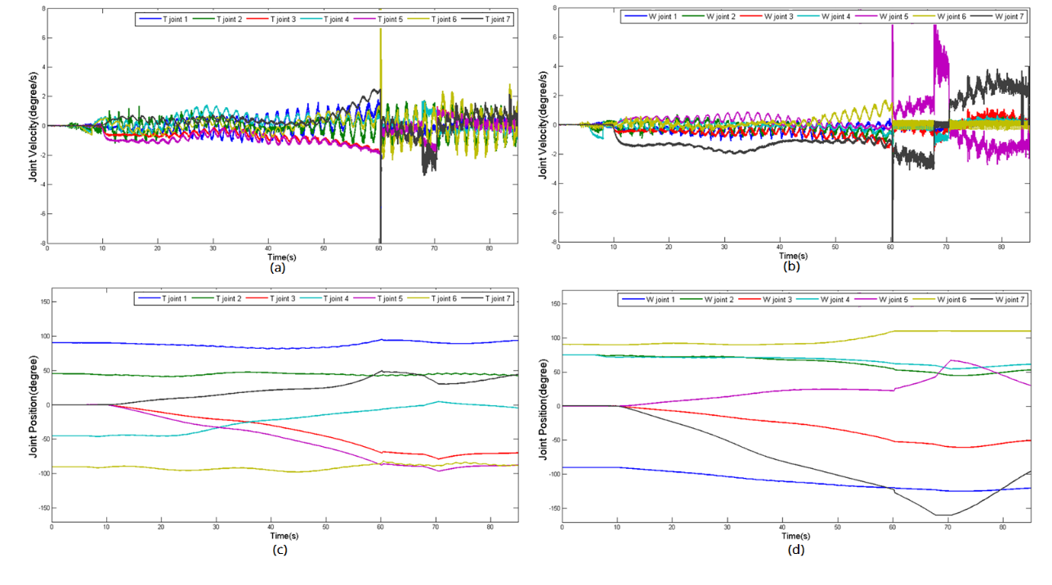

Fig.5.7. (a) Tool robot joint velocity. (b) Workpiece robot joint velocity.

(c) Tool robot joint position. (d) Workpiece robot joint position.

**5.4 Conclusion**

In this paper, a task-priority framework for handling task conflicts and joint constraints of a dual-arm robot is proposed. This co-operative control frame is based on the relative Jacobian formulation, singularity-robust inverse kinematics and the scheme of distributing exceeded joint velocity in null space. This work contributes a framework to handle multi-tasking conflicts both in task and joint space for dual-arm robots. We show that this framework is efficient in solving task conflict by implementing it on a simulation environment as well as a real robot platform.

There are several possible directions of further developments of this framework. In order to increase the control smoothness, it is possible to move the framework to acceleration level. In addition, the current method used in this framework relies on the assumption that the desired null space velocity is closed to the actual null space velocity; however, this is not always true due to robotic dynamics. To achieve true null space optimization, a null space velocity control scheme and the use of the inertia weighted pseudoinverse [21] can be investigated.

It is also possible to design a task division scheme which considers the nature of the task as well as the competiveness of each robot arm. During the experiments conducted in this study, it is found that the performance of each robot in terms of tracking error is configuration dependent; therefore, an optimization in null space, for increasing task compatibility of each robot may be necessary

6 A Suturing Device with Programmable Needle Trajectory

**6.1 Requirements Analysis**

In conventional suturing using a circular needle, a difficult part is driving the needle from the entrance point to the exit point and simultaneously minimizing deformation caused on tissue. The time and cost associated with attaching these sutures is high when many hundreds or thousands of sutures are applied, so it is desired a device to be designed, which can drive the circular needle automatically and make knot tying easy.

Recently, there are several suturing devices seen to be designed with automated mechanisms that drive a circular needle. These devices include [Endo360°](http://endoevolution.com/endo360/) [16] ([EndoEvolution, LLC](http://endoevolution.com/endo360/" \t "_blank), Raynham USA), Sutrue® [20] (Sutrue LTD, Essex, UK) and a device recently patented (Ethicon Endo-Surgery, Inc. US). With these devices, the awkward operation of driving a circular needle is not necessary, which is extremely useful in minimally invasive surgery with limited degree-of-freedom and operation space. Even though many different mechanisms are designed for driving the circular needle, all devices perform stitching by repeat the same motion rotating a circular needle around its centre axis. According to the review in Chapter 3, this type needle trajectory is too conservative, since it cannot adapt stitch sizes and depths to drive the needle to a pre-selected exit point accurately. Inspired by the work of suturing path planning (Jackson et al. [23]), a suturing device with programmable needle trajectory is prototyped and presented in this chapter.

In order to sew small stitch size with a relative big needle, for example 1mm stich and Ø10mm needle, the needle should be reoriented during stitching. One method is reorienting the needle according to a fixed point. For example, the point can be selected near the stitching entrance point to minimize fabric deformation (Fig. 6.1). Actually with this needle driving method, the needle can be driven to any exit point within the reachability of a curved needle; therefore, a variety of stiches can be sewed.

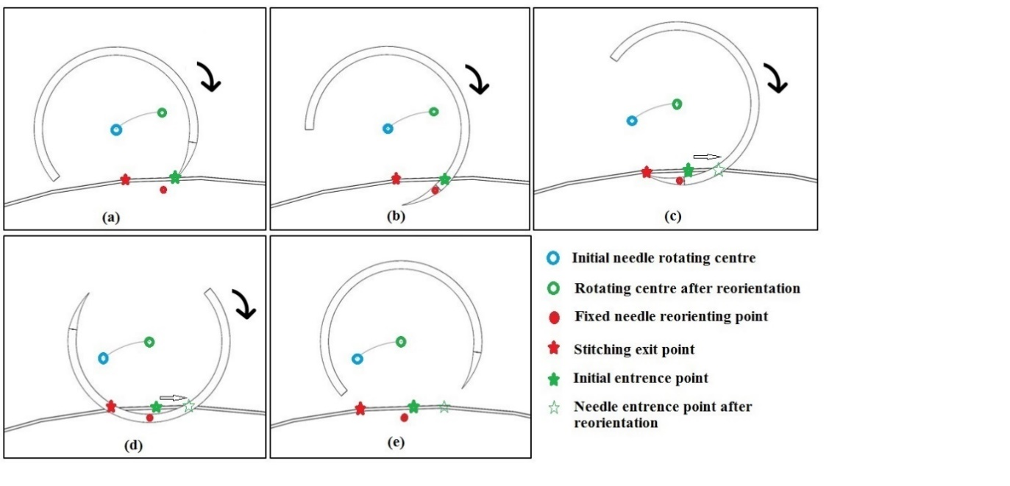

Fig. 6.1 Needle trajectory: (a) Approaching the entrance point. (b) Piercing the surface. (c) Reorienting the needle around a fixed point. (d) Reach the exit point. (e) Retrieving the needle.

**6.2 Prototyping**

Based on our assumption and analysis, we envision that a motorized device which drives the needle with a critical planned trajectory would have great potential use. This device is small, thin, and used like a pen so that it can either be hand held or robot mounted. A prototype of the described suturing device is designed as Fig 6.2. This device is 150mm long, 14mm thick, with two-degree-of-freedom: one is responsible for rotating a 260º circular needle around its centre;

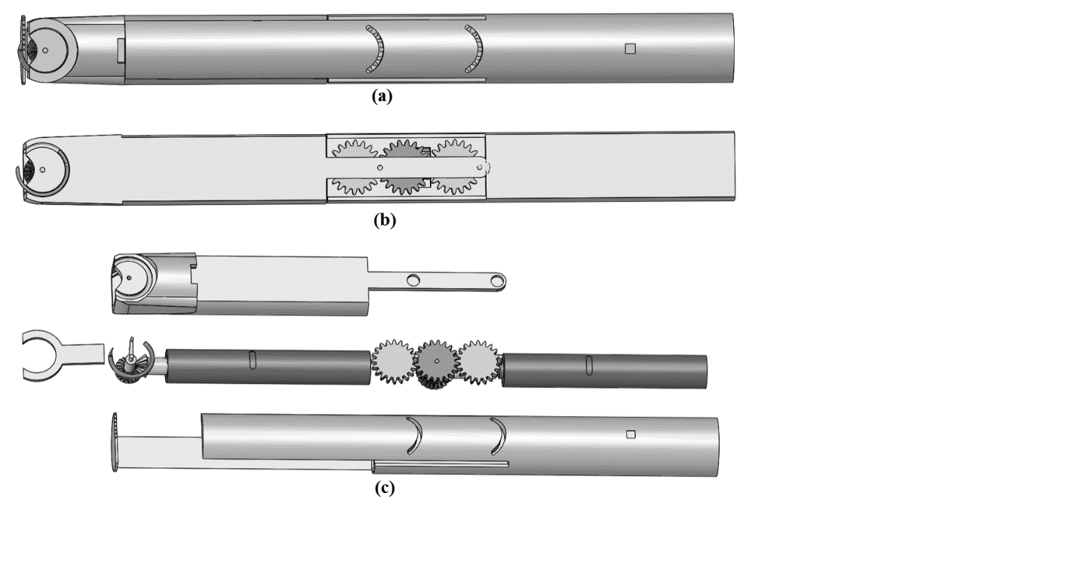

Fig. 6.2 (a) Integrated view (b) section view (c) exploded view

the other for reorienting the needle according to a point on the needle body and near its tip. One stitching period is shown in Fig. 6.3.

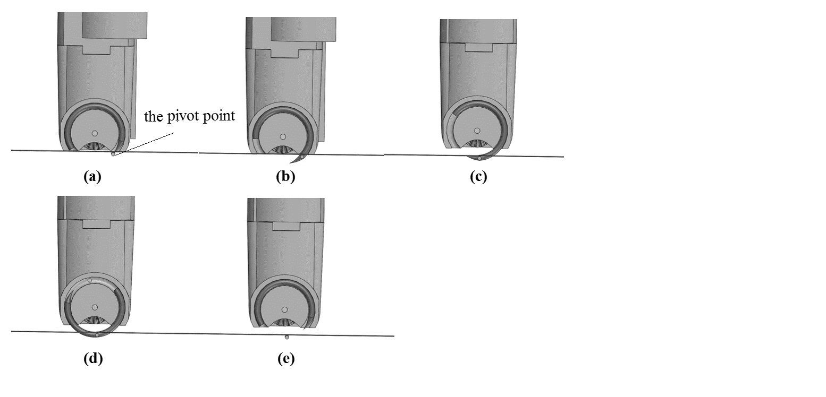

Fig. 6.3 One stitching period

To drive a circular needle, there are two mechanism to be selected, for example, using a pairs of rollers working together to grip a needle and rotate it, or using a pin to push a needle with notches on its body. In this initial design, we take the second solution (Fig.6.4) because with this method, the position of the needle can be accurately controlled. There are two notches on the needle body, 180º apart. The notch has a slope towards the end side of the needle. By rotating the pin forward and backward with 180º each time, the needle can be driven to perform continuous stitching.

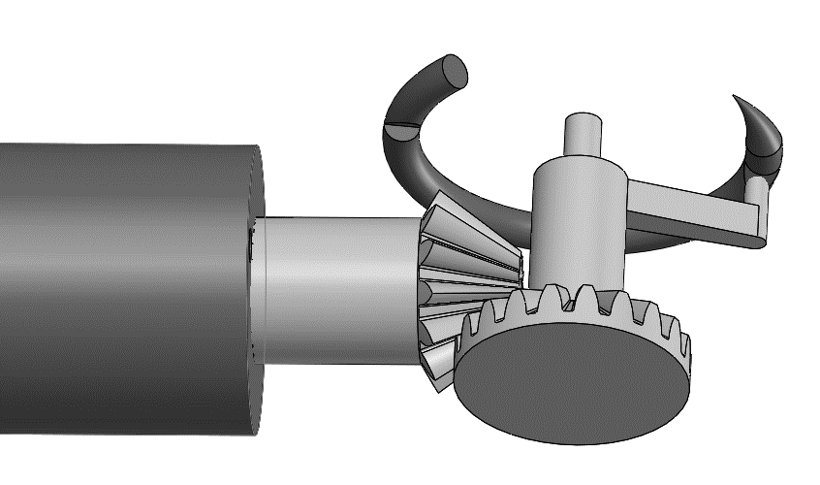

Fig. 6.4 Needle driving mechanism

The needle reorienting mechanism rotates the needle around a fixed axis, and usually this point is under the surface being sewed. A three-gear-transmission mechanism is designed to reorient the needle. The merit of this design is that there is no need to place a physical pivot on the rotating axis. There are two solutions to drive the device. The first one uses Ø8mm, 48mm long Faulhaber rotatory motor and bevel gear transmission (Fig. 6.5 a). The second one uses 8mm thick, 60 mm long Faulhaber linear motor and Scotch yoke transmission (Fig. 6.5 b). The first solution makes the design shorter; however, manufacturing such small bevel gears is highly demanding on machine accuracy. The second solution using linear motor nevertheless makes the design longer, but its merit is obvious on less demanding on manufacturing accuracy and saving more space.

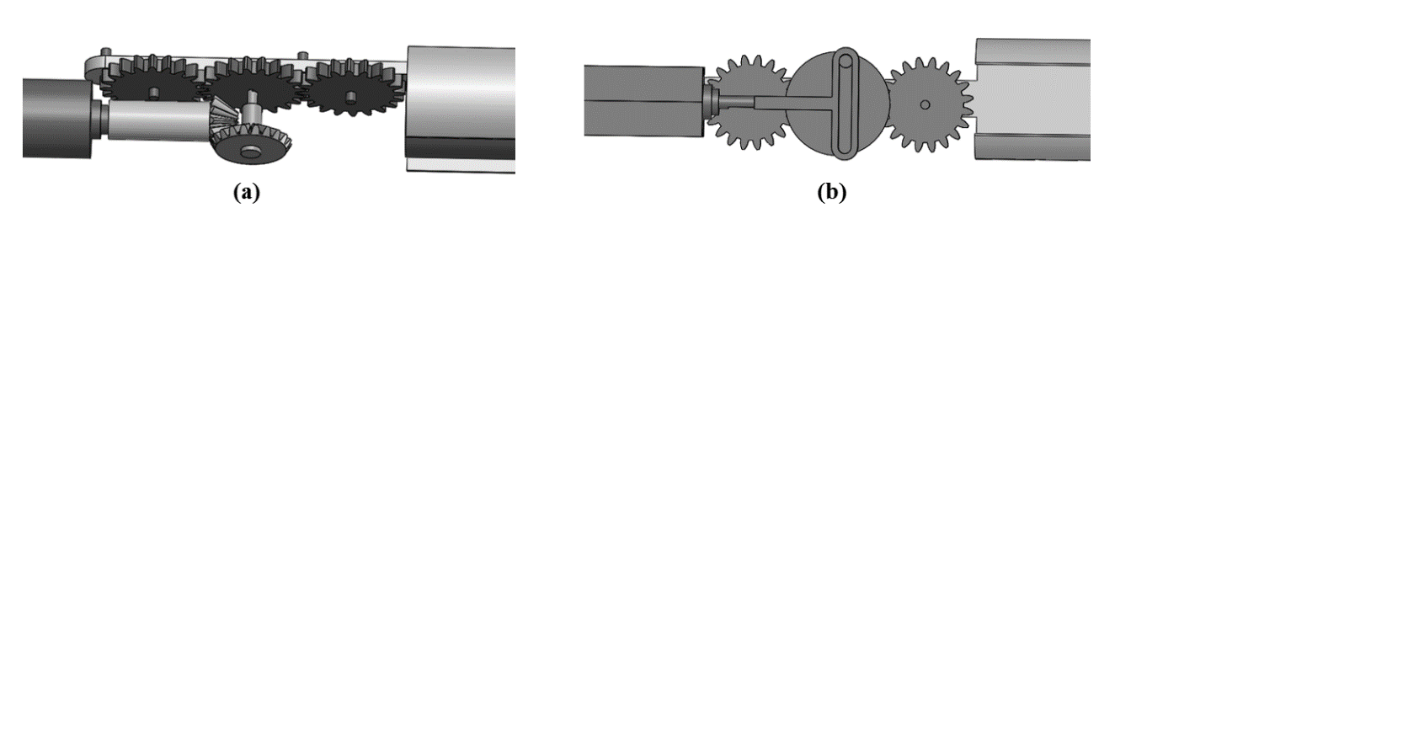

Fig. 6.5 Needle reorienting mechanism (a) Bevel gear transmission (b) Scotch yoke transmission

Before making the handware, further work needs to be done in three aspects. Firstly, to make this device suitable for the scale of task like stent graft sewing, geometrical constraints should be thoroughly analysed, for example the stent diameter and fabric thickness. These constraints can be used as guidance to select the needle diameter, position of the reorienting point as well as the needle’s working space. Secondly, inverse kinematic of the two-degree-of-freedom device should be modelled so that the planned trajectory can be executed precisely. Thirdly, as the tip of this device moves in the air, a reference point needs to be created, which is able to show where the target entrance and exit point are. Perhaps, a laser beam projected on the sewn object is a potential solution. Fig 6.6 is a visionary scenario when using this device to sew a stent graft.

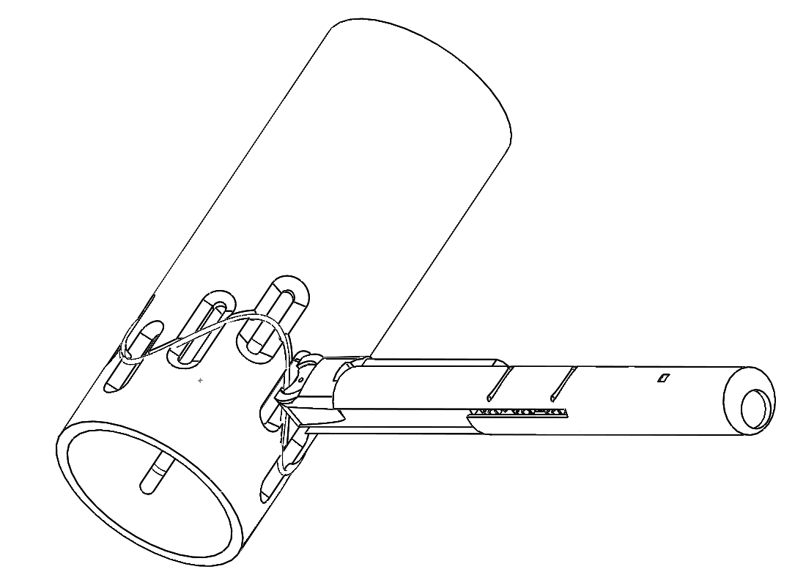

Fig. 6.6 A visionary scenario when using this device to sew a stent graft. A stent is fixed in the mandrel slot.

The fabric is warped outside the mandrel.

7 Conclusion and Future Work

This report starts with reviewing state-of-the-art technologies on automating stent graft manufacturing and also summarizes the limitations on current stage. Then, in chapter 3 and 4, the survey goes more broadly into reviewing the innovations on automated industrial sewing and medical suturing. In chapter 5, our work on using bimanual robot to manufacture stent graft is introduced and the preliminary result which is presented as a paper in IROS 2015 is shown. In chapter 6, we show the prototyping of a new device which could possibility innovate stent graft sewing process.

According to this review, hand sewing technique and relevant running and tacking methods are more proper way to sew fenestrated/branched stent grafts in terms of elegancy, strength and versatility. As such, our investigation starts with researching on the ways to transfer the hand sewing skills to a bimanual robot. The research topics on robot co-cooperative planning, control and Learning from Demonstration all play important roles in the skills transfer process. From a system-level point of view, the robotic sewing system should be able to handle constraints on its kinematic, dynamics, task requirements and properly exploit its kinematic redundancy for optimizing the execution of bimanual sewing in the low level. On the higher level of machine learning and skill acquisition, the robot should be able to learn the sewing easily and naturally by observing human’s demonstration rather than by hard coding a fixed policy. And the learned skills should also be robust and able to generalize even to unmet situations without reprogramming. According to this, another team member--Dr. Huang, and me are collocating yet dedicating in each other’s expertise filed – Machine Learning and Co-operative Control – to achieve the eventual transferring human sewing skills to a bimanual robot.

Parallel to researching on robotic sewing with conventional needle drivers, we are also investigating on prototyping a mechanical device to automate the sewing/suturing process. This novel device could simply the most complex procedure – needle trajectory control/planning – in conventional robotic suturing. With programmable stitch sizes and stitching depth, robot manipulator mounted this device could potentially deal with the stent graft sewing task precisely and efficiently.

To really automate the process for fenestrated/branched stent graft sewing either using conventional sewing method or the newly prototyped device, merely researching on skill transfer is not enough. The robot should be able to sense and feel the sewing environment in order to adapt to its changes. Vision guidance/visual servoing plays a key role in the subtasks of running stitches following the stent, regrasping the needle, and tying knots. This research on vision guided sewing is interesting, challenging yet very valuable, which is not limited for sewing stent graft but has more broad applications in robotic surgery. The developing of a hierarchical vision system with both global and local guidance is ongoing. Researching on this novel vision guided system has both great theoretical and practical value.

Reference

[1]http://[www.ksl-lorsch.de/en/products/automotive/composites/blindstitch-head-rc-510/](http://www.ksl-lorsch.de/en/products/automotive/composites/blindstitch-head-rc-510/)

[2]Padoy, Nicolas, and Gregory D. Hager. "Human-machine collaborative surgery using learned models." Robotics and Automation (ICRA), 2011 IEEE International Conference on. IEEE, 2011.

[3]Havel, William John. "Attachment of stent to graft fabric with an anchoring machine stitching." U.S. Patent Application 13/772,009.

[4] Anson, Anthony Walter. "Surgical graft/stent system." U.S. Patent No. 6,334,867. 1 Jan. 2002.

[5]Murai, Estevan Hideki, Daniel Martins, and Henrique Simas. "NUMBER AND TYPE SYNTHESES FOR AN ONE-SIDE STITCHING DEVICE." (2013).

[6]Parallel Kinematic Sewing the Institute of Textiles, University RWTH Aachen

[7]Gershon, D., and I. Porat. "Robotic sewing using multi-sensory feedback."Proc. 16th International Symposium on Intelligent Robotics, Brussels. 1986.

[8]Gershon, David, and Isaac Porat. "Vision servo control of a robotic sewing system." Robotics and Automation, 1988. Proceedings., 1988 IEEE International Conference on. IEEE, 1988.

[9]Kudo, Makoto, et al. "Multi-arm robot control system for manipulation of flexible materials in sewing operation." Mechatronics 10.3 (2000): 371-402.

[10]Schrimpf, Johannes, and Lars Erik Wetterwald. "Experiments towards automated sewing with a multi-robot system." Robotics and Automation (ICRA), 2012 IEEE International Conference on. IEEE, 2012.

[11]Schrimpf, Johannes, Lars Erik Wetterwald, and Morten Lind. "Real-time system integration in a multi-robot sewing cell." Intelligent Robots and Systems (IROS), 2012 IEEE/RSJ International Conference on. IEEE, 2012.

[12]Schrimpf, Johannes, Magnus Bjerkeng, and Geir Mathisen. "Velocity coordination and corner matching in a multi-robot sewing cell." Intelligent Robots and Systems (IROS 2014), 2014 IEEE/RSJ International Conference on. IEEE, 2014.

[13]Biegelbauer, Georg, et al. "Optical seam following for automated robot sewing."Robotics and Automation, 2007 IEEE International Conference on. IEEE, 2007.

[14]Koustoumpardis, Panagiotis, Nikos Aspragathos, and Paraskevi Zacharia.Intelligent robotic handling of fabrics towards sewing. INTECH Open Access Publisher, 2006.

[15]<http://www.covidien.com/surgical/products/single-incision-laparoscopic-surgery/sils-stitch>

[16]<http://endoevolution.com/>

[17]<http://apolloendo.com/products/overstitch/>

[18]Legner, Andras, et al. "Transoral Mucosal Excision Sutured Gastroplasty A Pilot Study for GERD and Obesity With Two-Year Follow-Up." Surgical innovation 21.5 (2014): 456-463.

[19]<http://www.bostonscientific.com/en-US/products/pelvic-floor-reconstruction/capio-slim.html>

[20]http://www.sutrue.com/

[21]Jernigan, Shaphan R., et al. "A laparoscopic knot-tying device for minimally invasive cardiac surgery." European Journal of Cardio-Thoracic Surgery 37.3 (2010): 626-630.

[22]<http://www.ethicon.com/healthcare-professionals/products/wound-closure/suture-assist/suture-assistant>

[23]Jackson, Russell C., and M. Cenk Cavusoglu. "Needle path planning for autonomous robotic surgical suturing." Robotics and Automation (ICRA), 2013 IEEE International Conference on. IEEE, 2013.

[24]Kapoor, Ankur, and Russell H. Taylor. "A constrained optimization approach to virtual fixtures for multi-handed tasks." Robotics and Automation, 2008. ICRA 2008. IEEE International Conference on. IEEE, 2008.

[25]Nageotte, Florent, et al. "A circular needle path planning method for suturing in laparoscopic surgery." Robotics and Automation, 2005. ICRA 2005. Proceedings of the 2005 IEEE International Conference on. IEEE, 2005.

[26]Nageotte, Florent, et al. "Stitching planning in laparoscopic surgery: Towards robot-assisted suturing." The International Journal of Robotics Research (2009).

[27]Chow, Der-Lin, and Wyatt Newman. "Improved knot-tying methods for autonomous robot surgery." Automation Science and Engineering (CASE), 2013 IEEE International Conference on. IEEE, 2013.

[28]Nagy, István, et al. "Endo [PA] R: An open evaluation system for minimally invasive robotic surgery." Mechatronics and Robotics. 2004.

[29]Mayer, Hermann, et al. "A system for robotic heart surgery that learns to tie knots using recurrent neural networks." Advanced Robotics 22.13-14 (2008): 1521-1537.

[30]Van Den Berg, Jur, et al. "Superhuman performance of surgical tasks by robots using iterative learning from human-guided demonstrations." Robotics and Automation (ICRA), 2010 IEEE International Conference on. IEEE, 2010.

[31]<http://www.paresurgical.com/>

[32]Jamisola, Rodrigo S., and Rodney G. Roberts. "A more compact expression of relative Jacobian based on individual manipulator Jacobians." Robotics and Autonomous Systems 63 (2015): 158-164.

[33]Chiaverini, Stefano. "Singularity-robust task-priority redundancy resolution for real-time kinematic control of robot manipulators." Robotics and Automation, IEEE Transactions on 13.3 (1997): 398-410.

[34]Antonelli, Gianluca. "Stability analysis for prioritized closed-loop inverse kinematic algorithms for redundant robotic systems." Robotics, IEEE Transactions on 25.5 (2009): 985-994.

[35]Siciliano, Bruno, and Oussama Khatib, eds. Springer handbook of robotics. Springer Science & Business Media, 2008

[36]Antonelli, Gianluca, Giovanni Indiveri, and Stefano Chiaverini. "Prioritized closed-loop inverse kinematic algorithms for redundant robotic systems with velocity saturations." Intelligent Robots and Systems, 2009. IROS 2009. IEEE/RSJ International Conference on. IEEE, 2009.

[37]Flacco, Fabrizio, Alessandro De Luca, and Oussama Khatib. "Motion control of redundant robots under joint constraints: Saturation in the null space." Robotics and Automation (ICRA), 2012 IEEE International Conference on. IEEE, 2012.

[38]http://www.kuka-labs.com/NR/rdonlyres/310A3034-1F44-47D7-8B37-F681BFCF7757/0/db\_LBRiiwa\_en.pdf

[39] Choi, Youngjin. "Singularity-robust inverse kinematics using lagrange multiplier for redundant manipulators." Journal of Dynamic Systems, Measurement, and Control 130.5 (2008): 051009.

[40]Flacco, Fabrizio, and Alessandro De Luca. "A reverse priority approach to multi-task control of redundant robots." Intelligent Robots and Systems (IROS 2014), 2014 IEEE/RSJ International Conference on. IEEE, 2014.

[41]Nemec, Bojan. "Pseudoinverses and null space velocity controller." Intelligent Engineering Systems, 1997. INES'97. Proceedings., 1997 IEEE International Conference on. IEEE, 1997.

[42]Schulman, John, et al. "A case study of trajectory transfer through non-rigid registration for a simplified suturing scenario." Intelligent Robots and Systems (IROS), 2013 IEEE/RSJ International Conference on. IEEE, 2013.

[43]Osa, Takayuki, Naohiko Sugita, and Mitsuishi Mamoru. "Online Trajectory Planning in Dynamic Environments for Surgical Task Automation." Robotics: Science and Systems (RSS). 2014.

[44]Iyer, Srikrishna, Thomas Looi, and James Drake. "A single arm, single camera system for automated suturing." Robotics and Automation (ICRA), 2013 IEEE International Conference on. IEEE, 2013.

[45]Staub, Christoph, et al. "Automation of tissue piercing using circular needles and vision guidance for computer aided laparoscopic surgery." Robotics and Automation (ICRA), 2010 IEEE International Conference on. IEEE, 2010.

[46]Leonard, Simon, et al. "Smart tissue anastomosis robot (STAR): A vision-guided robotics system for laparoscopic suturing." Biomedical Engineering, IEEE Transactions on 61.4 (2014): 1305-1317.

[47]Lo, Diego, Paulo RS Mendonça, and Andy Hopper. "TRIP: A low-cost vision-based location system for ubiquitous computing." Personal and Ubiquitous Computing 6.3 (2002): 206-219.

[48] Philip Pratt, Archie Hughes-Hallett, Lin Zhang, Nisha Patel Erik Mayer, Ara Darzi, and Guang-Zhong Yang "Autonomous Ultrasound-Guided Tissue Dissection." Medical Image Computing and Computer-Assisted Intervention–MICCAI 2015.

[49]Reiter, Austin, Peter K. Allen, and Tao Zhao. "Appearance learning for 3d tracking of robotic surgical tools." The International Journal of Robotics Research (2013): 0278364913507796.

[50]Yang Hu, Bidan Huang, and Guang-Zhong Yang. "Task-Priority Redundancy Resolution for Co-operative Control under Task Conflicts and Joint Constraints." Intelligent Robots and Systems (IROS 2015), 2015 IEEE/RSJ International Conference on. IEEE, 2015.

[51]Phillips, Peter, et al. "Method for manufacturing stent-grafts." U.S. Patent No. 7,073,456. 11 Jul. 2006.

[52]Stefanchik, David, and James A. Craft. "Suturing device." U.S. Patent No. 8,211,143. 3 Jul. 2012.

[53]Eguchi, Yasukata, et al. "Suturing machine for medical treatment." U.S. Patent No. 4,414,908. 15 Nov. 1983.

[54]Jackson, Benjamin M., and Jeffrey P. Carpenter. "Devices used for endovascular aneurysm repair: past, present, and future." Seminars in interventional radiology. Vol. 26. No. 1. Thieme Medical Publishers, 2009.

[55]Murali, Adithyavairavan, et al. "Learning by observation for surgical subtasks: Multilateral cutting of 3d viscoelastic and 2d orthotropic tissue phantoms." Int. Conf. on Robotics and Automation (ICRA). 2015.

[56]Ding, Jienan, and Nabil Simaan. "Choice of handedness and automated suturing for anthropomorphic dual-arm surgical robots." Robotica: 1-19.

[57]Khabbaz, Faezeh Heydari, and Alexandru Patriciu. "Stitching path planning using circular needles-tissue interaction model." Robotics and Biomimetics (ROBIO), 2011 IEEE International Conference on. IEEE, 2011.

[58]Martell, John, et al. "Visual measurement of suture strain for robotic surgery."Computational and mathematical methods in medicine 2011 (2011).

[59]Kang, Hyosig, and John T. Wen. "Robotic knot tying in minimally invasive surgeries." Intelligent Robots and Systems, 2002. IEEE/RSJ International Conference on. Vol. 2. IEEE, 2002.

[60]Wang, Shuxin, Huijuan Wang, and Longwang Yue. "A novel knot‐tying approach for minimally invasive surgical robot systems." The International Journal of Medical Robotics and Computer Assisted Surgery 4.3 (2008): 268-276.

[61]Bell, Matthew, and Devin Balkcom. "Knot tying with single piece fixtures."Robotics and Automation, 2008. ICRA 2008. IEEE International Conference on. IEEE, 2008.

[62]Masterson, B. J. Operative Gynecologic Endoscopy. Eds. Joseph Sanfilippo, and Roland L. Levine. Springer, 2013.

[63]Fossum, Theresa Welch. Small animal surgery textbook. Elsevier Health Sciences, 2013.

[64]Dorland, William Alexander Newman. Dorland's Illustrated Medical Dictionary32: Dorland's Illustrated Medical Dictionary. Elsevier Health Sciences, 2011.